Tiny Arm

Assembly instructons

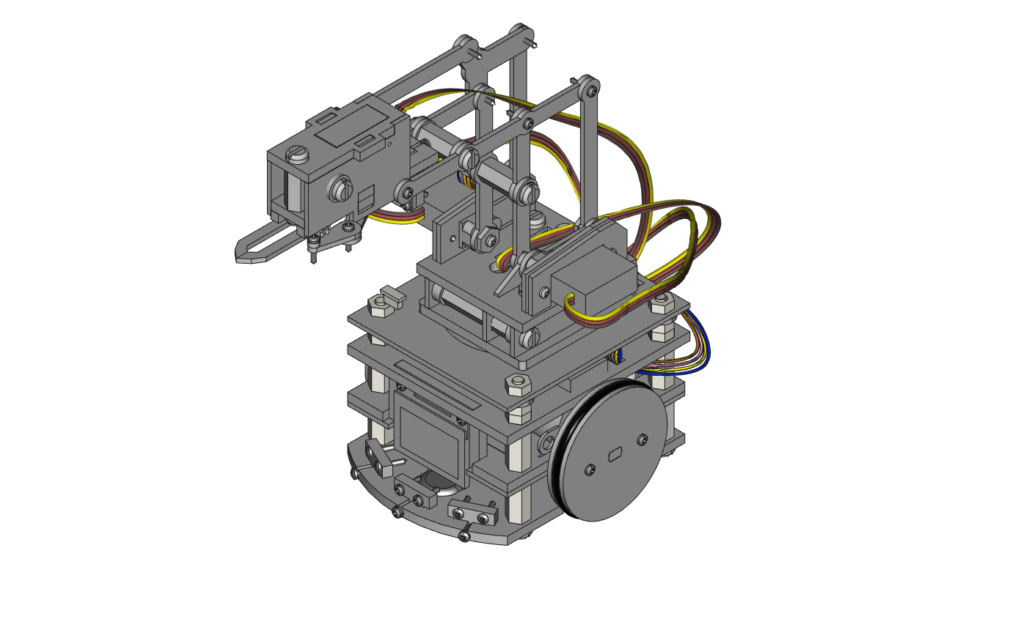



Kit Contents

* Large Hardware Kit
  + 10x ½” Aluminum Hex Standoff [#6-32]
  + 4x ¼” Aluminum Hex Standoff [#6-32]
  + 1x 1” Aluminum Hex Standoff [#6-32]
  + 18x 3/8” Slotted Nylon Screw [#6-32]
* Small Hardware Kit
  + 4x 1/32” Small Black O-Rings
  + 4x 3mm Acrylic Spacers
  + 30x M1.4 8MM Steel Tapping Screws
  + 30x Stainless Steel Washers
* Electronics
  + 1x 200mm 5-pin Wireling cable (for TOF Distance Wireling)
  + 1x 100mm 5-pin Wireling cables (for 0.96” OLED Screen Wireling)
  + 1x 1000mAh Battery
  + 1x RobotZero Processor
  + 4x EMAX ES9051 4.1G Digital Servos (Servo Mounting Kits included in each box)
* Required Tools
  + 1x Small Philips screwdriver for M1.4 x 8mm screws
* Recommended Tools
  + 1x Large flathead screwdriver for nylon screws
  + 1x Tweezers for small parts and routing cables
* Thin Acrylic Components [1/16”]
  + 1x AB2 part
  + 1x AB3 part
  + 1x AB4 part
  + 1x AB7 part
  + 1x AB8 part
  + 1x AB9 part
  + 1x AB10 part
  + 1x AB11 part
  + 1x A1
  + 1x A2
  + 1x A3
  + 1x A4
  + 1x A5
  + 1x A6
  + 1x A7
  + 1x A8
  + 1x A9
  + 1x CL3 part
  + 1x CL4 part
  + 1x CL6 part
  + 1x CL7 part
  + 1x CL8 part
  + 1x CL9 part
  + 1x CL10 part
  + 4x E parts (extras included)
  + 12x Thin spacers (extras included)
* Thick Acrylic Components [1/8”]
  + 1x AB1 part
  + 1x AB5 part
  + 1x AB6 part
  + 1x CL1 part
  + 1x CL2 part
  + 1x CL5 part
  + 1x CL11 part
  + 1x BA1
  + 1x BA2
  + 1x BA3
  + 2x S part (extra included)
  + 4x Thick spacers (extras included)
  + 1x B0
* Thick Acrylic Components [10 × 0.118”]
  + 1 × AB1 part
  + 1 × AB5 part
  + 1 × AB6 part
  + 1 × CL1 part
  + 1 × CL2 part
  + 1 × CL5 part
  + 1 × CL11 part
  + 1 × BA1
  + 1 × BA2
  + 1 × BA3
  + 2 × S part (extras included)
  + 4 × Thick spacers (extras

**STEP 0**: **Remove Acrylic Covering**. Once the paper is removed, try your best not to directly touch the acrylic (handle by the edges) as fingerprints show easily.

Visit our website at <https://tinycircuits.com> or email us at [info@tinycircuits.com](mailto:info@tinycircuits.com) for questions or help

**STEP 1**: Insert part AB2 into the slots highlighted on AB1.

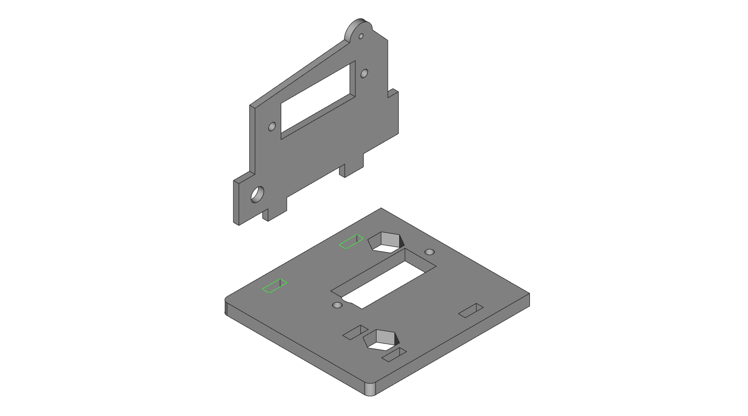

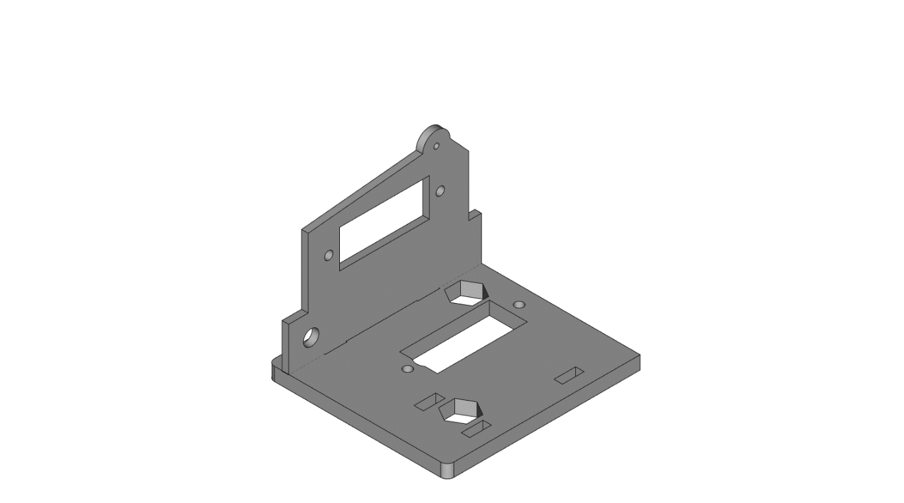

**STEP 2**: Insert AB3 into the slots highlighted on AB1.

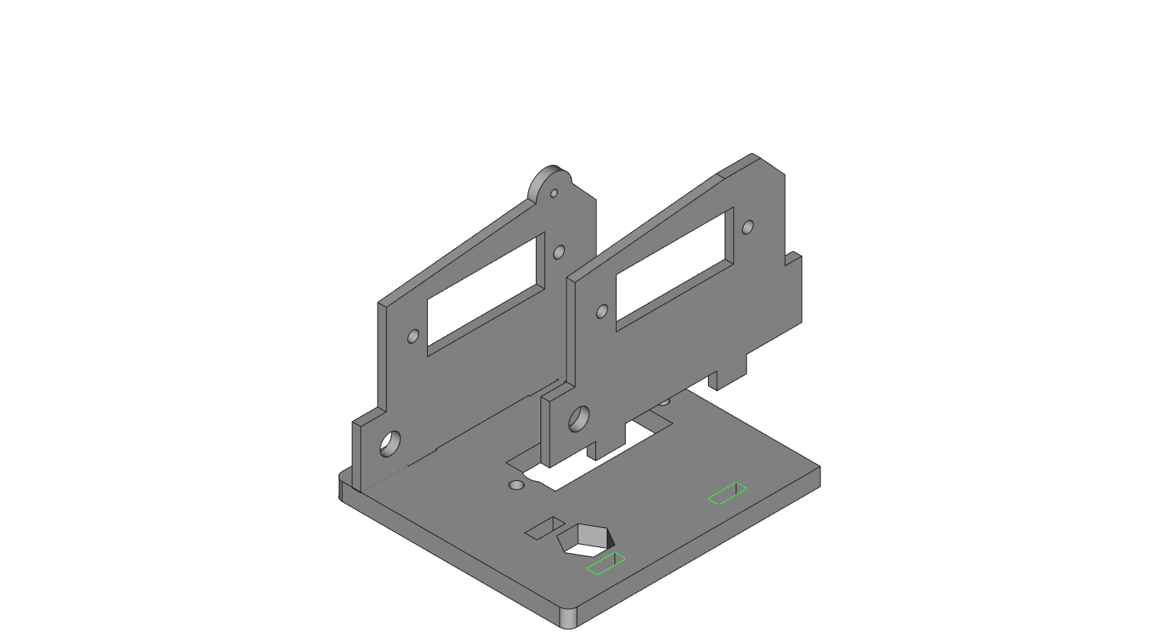

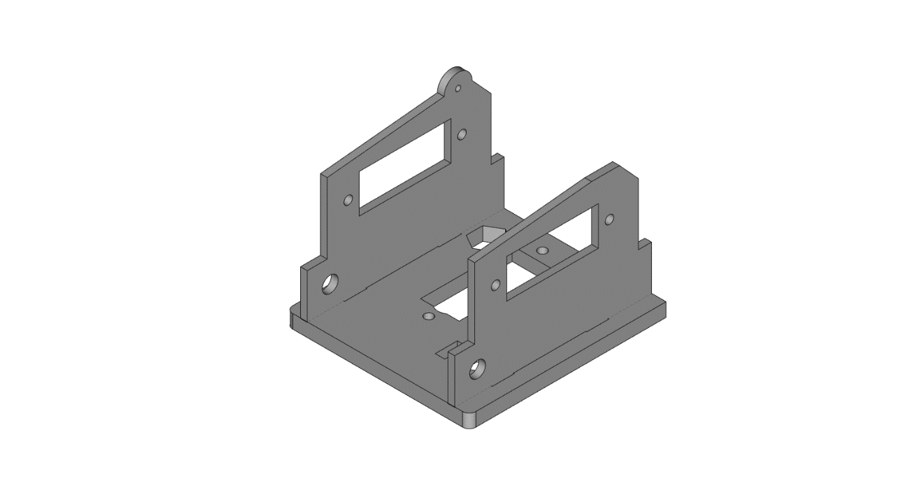

**STEP 3**: Insert a 1” aluminum hex standoff into part AB4, then insert it into the highlighted slot on part AB1.

*NOTE: Be careful when inserting the hex standoff into AB4, as it can crack the acrylic when forced with pressure. To insert carefully, lay A4 on a flat surface while inserting the hex standoff. Try pushing it through AB4 from the other side if one side seems too tight.*

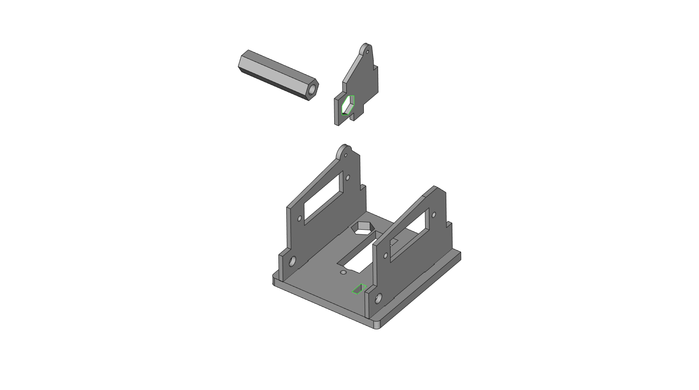

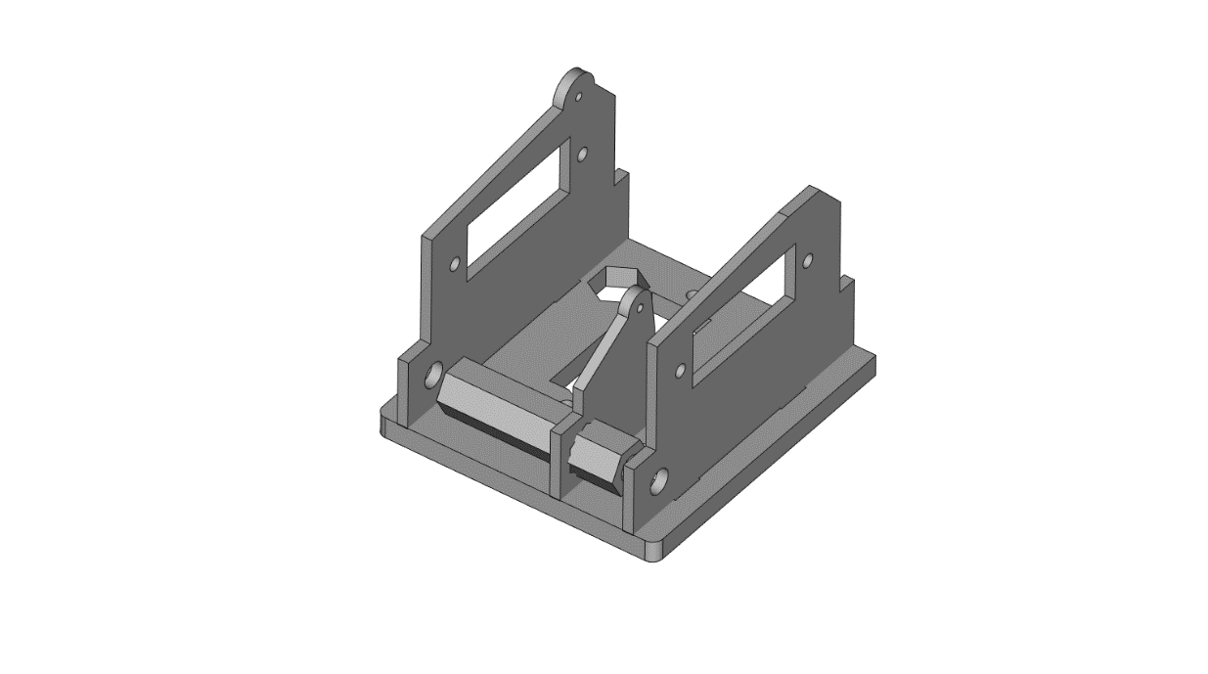

**STEP 4**: Use 2 thick acrylic spacers on each side of the 1” hex standoff to thread 2 nylon screws through the holes in AB2 and AB3, and into the hex standoff.

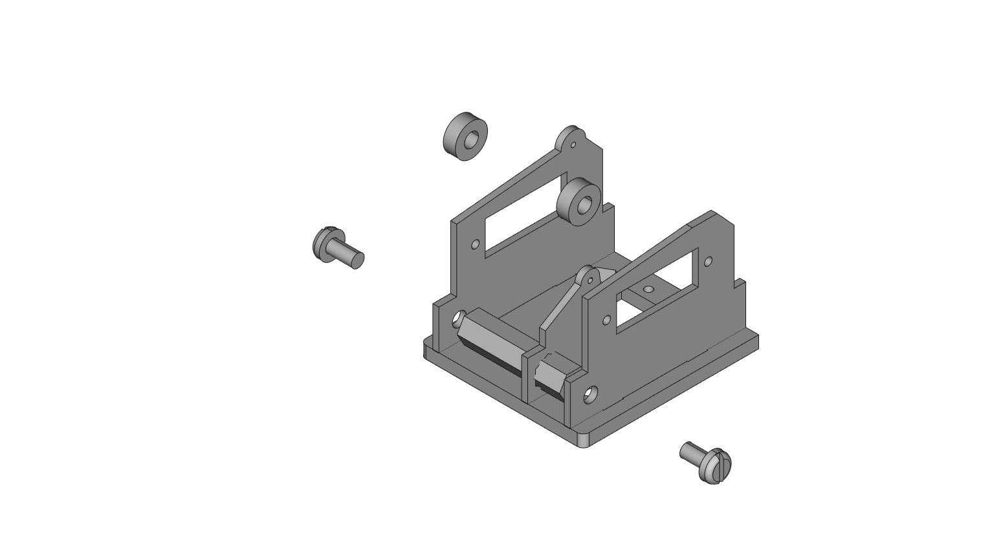

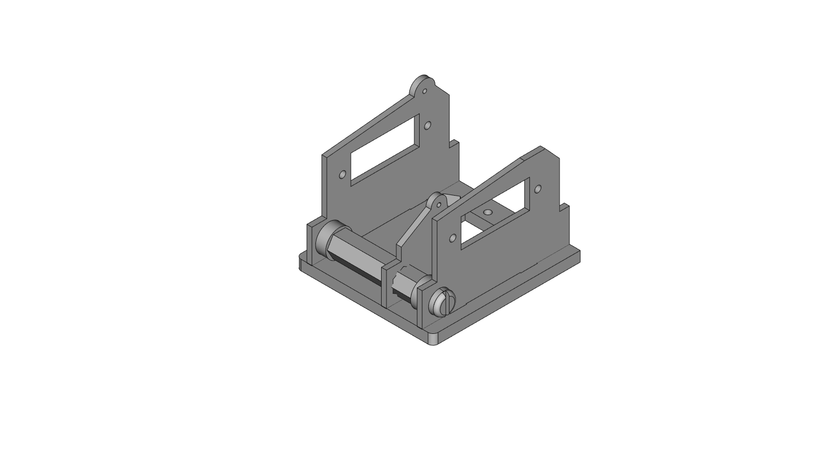

**STEP 5**: Slide part AB5 on top of the structure, with parts AB2, AB3, and AB4 threading through the highlighted slots on AB5.

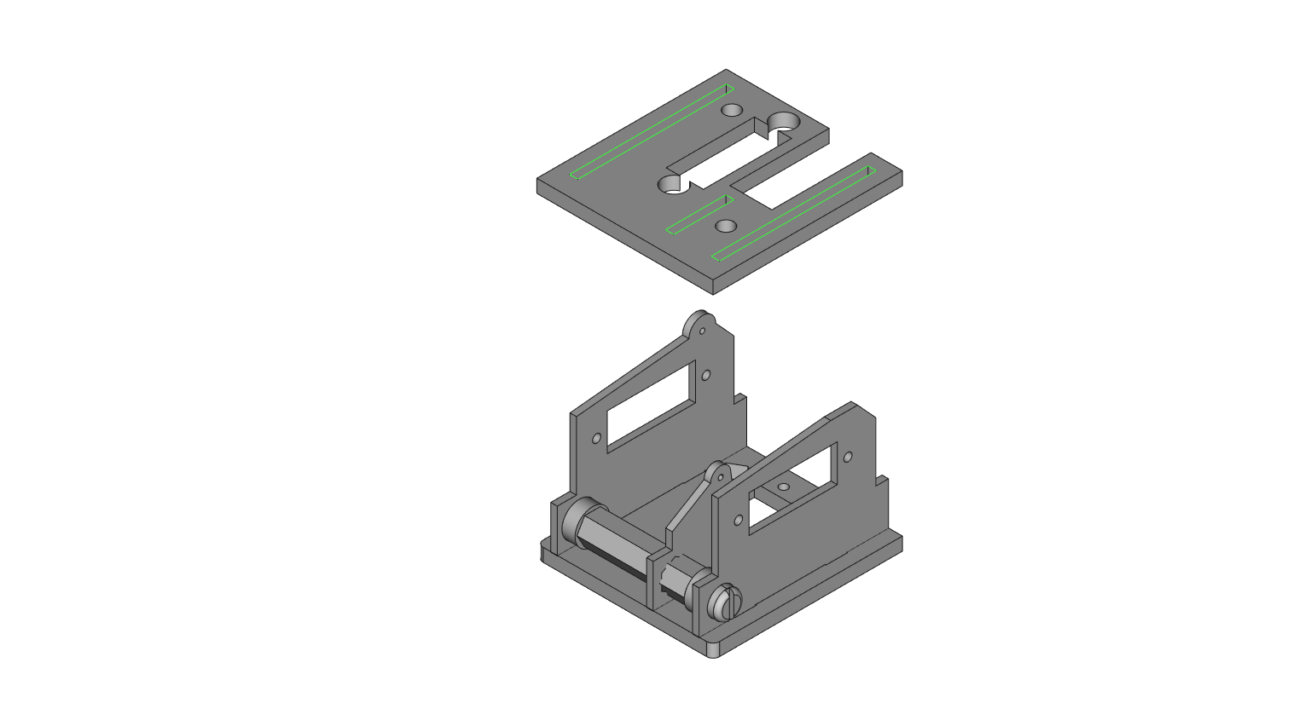

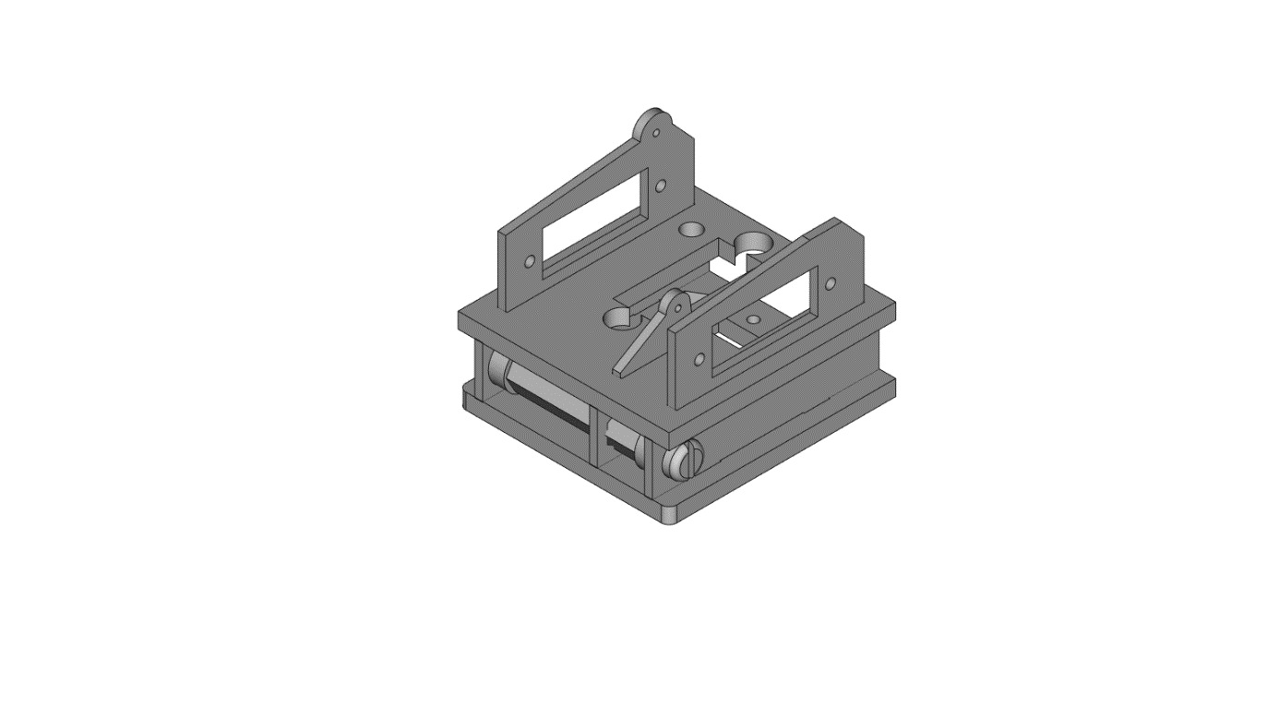

**STEP 6**: *NOTE: Calibrate all servos before continuing – to do this plug all servos into the RobotZero processor with a charged battery (to charge: plug the battery into the RobotZero, and plug the RobotZero into a power source using a Micro USB cable). When plugged in, the servos will be centered. Be careful not to move the output shafts once calibrated.*

Looking from the bottom of the current structure, insert 1 servo into the rectangle slot on part AB1. Thread the servo wire through AB1 and AB5, while paying close attention to the orientation in the below image. Use 2 large servo mounting screws from any of the servo mounting kits (included in each servo box) to thread them through the servo and AB1 into the highlighted holes.

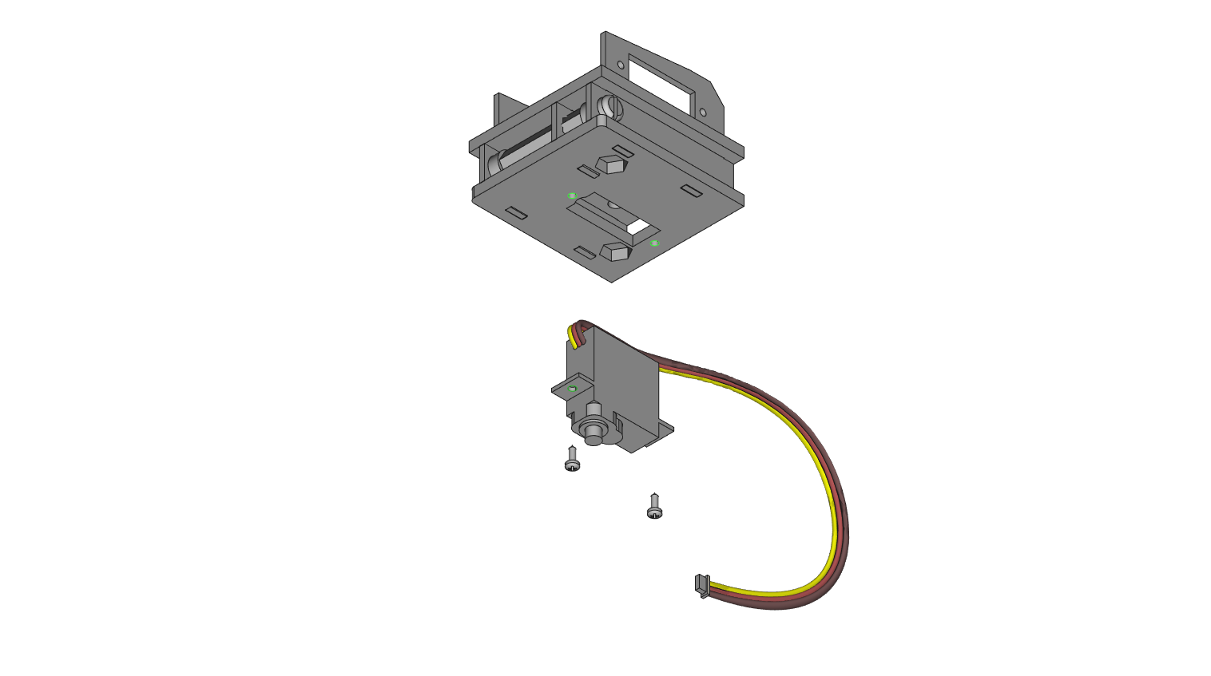

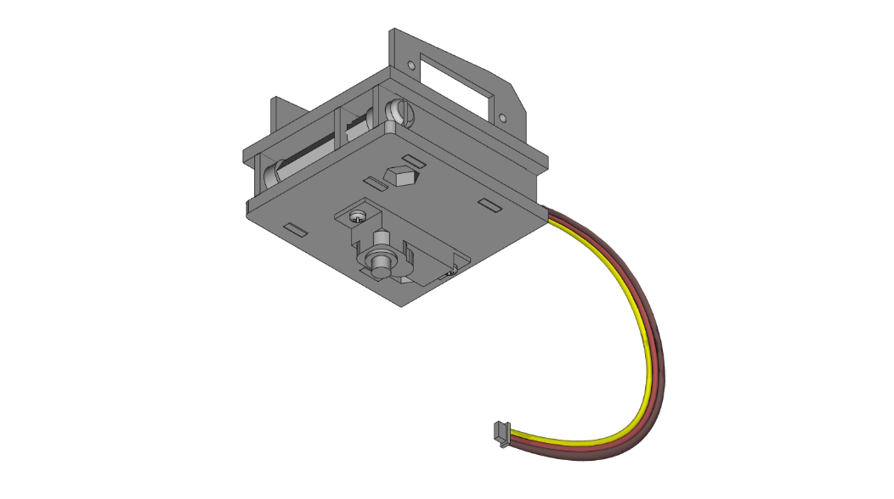

**STEP 7**: Place 2 1/2” aluminum hex standoffs into the hexagon outlines on the bottom of part AB1.

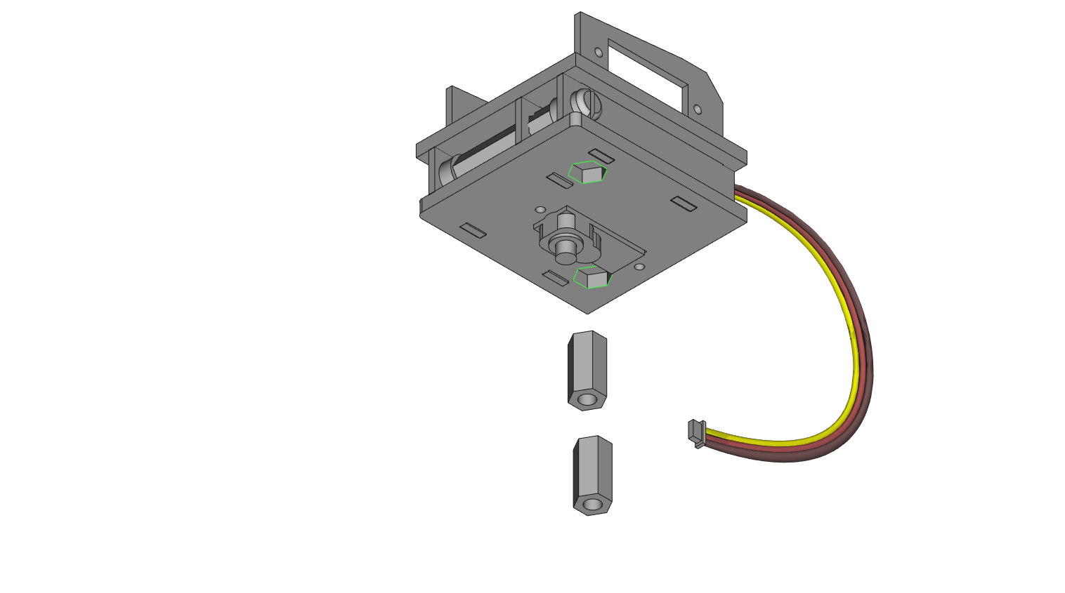

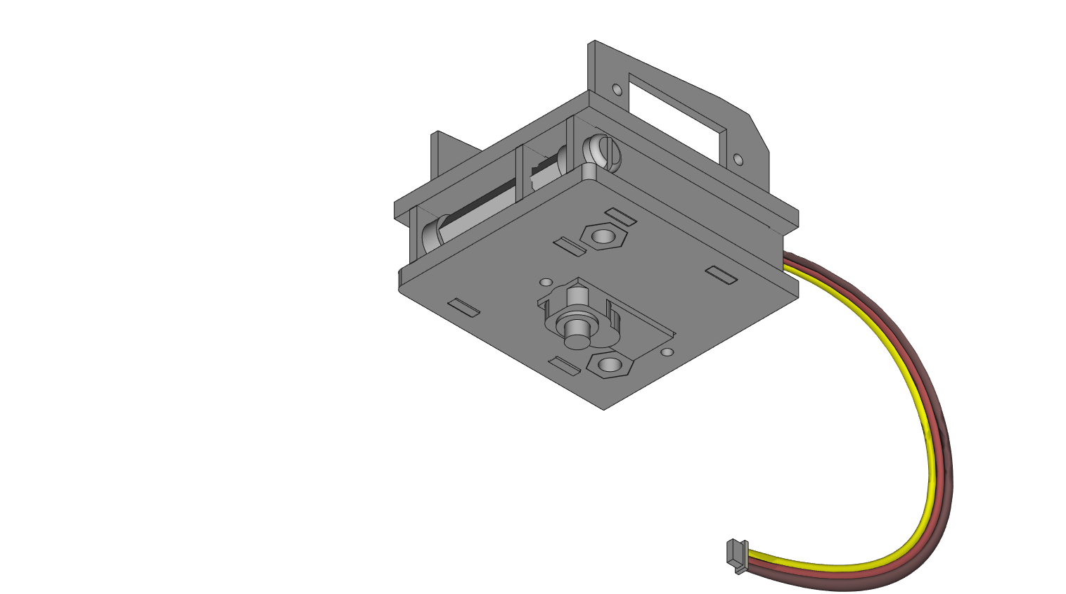

**STEP 8**: From the top, screw 2 white nylon screws through part AB5 into the hex standoffs from the previous step as highlighted.

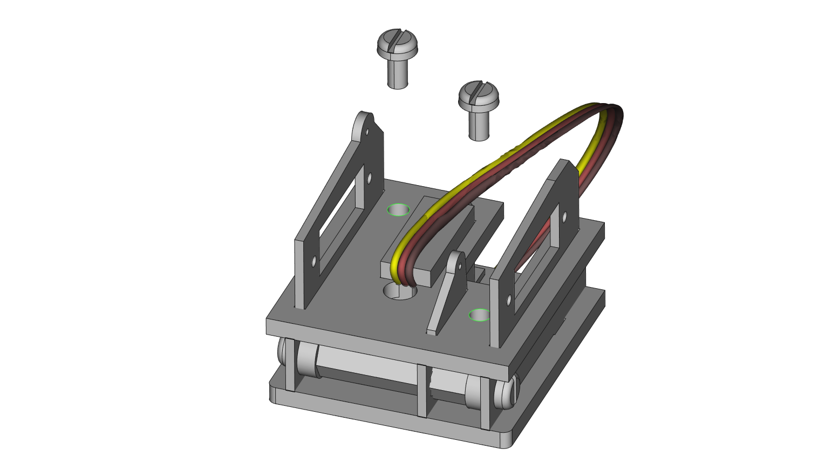

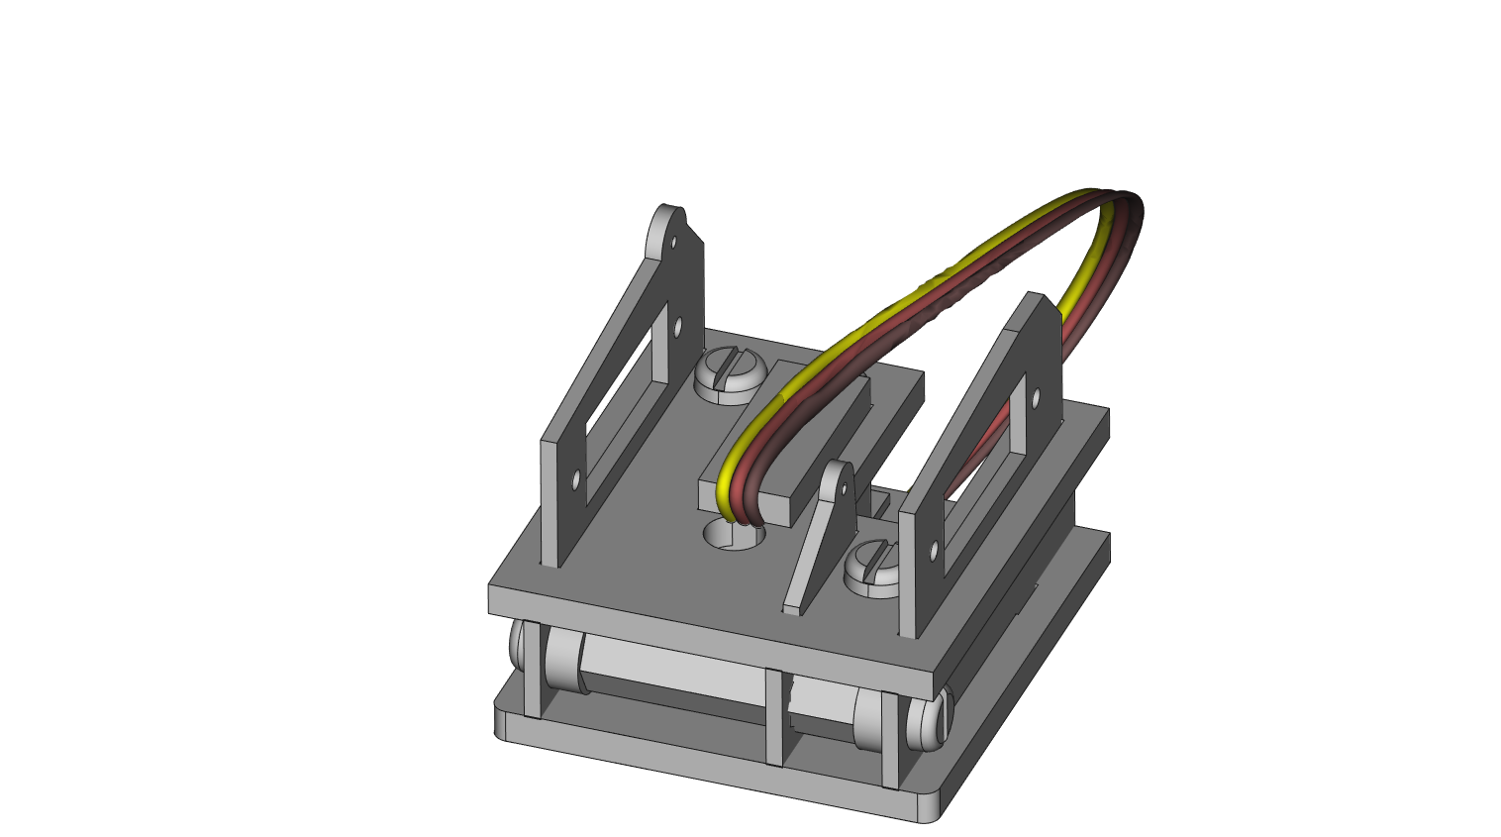

**STEP 9**: On the bottom, stack parts AB6 and AB7 on top of each other (the order does not matter) around the servo as shown below. Line the holes on the parts up with the holes on the 0.5” hex standoffs shown highlighted in green.

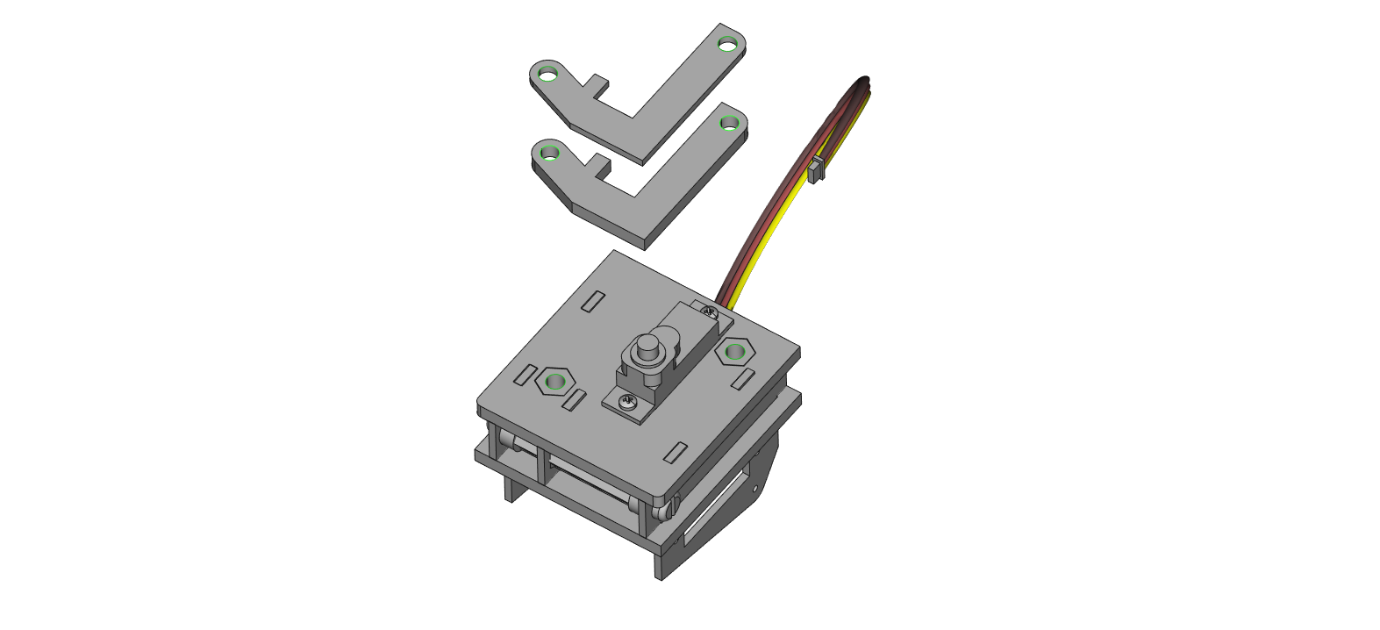

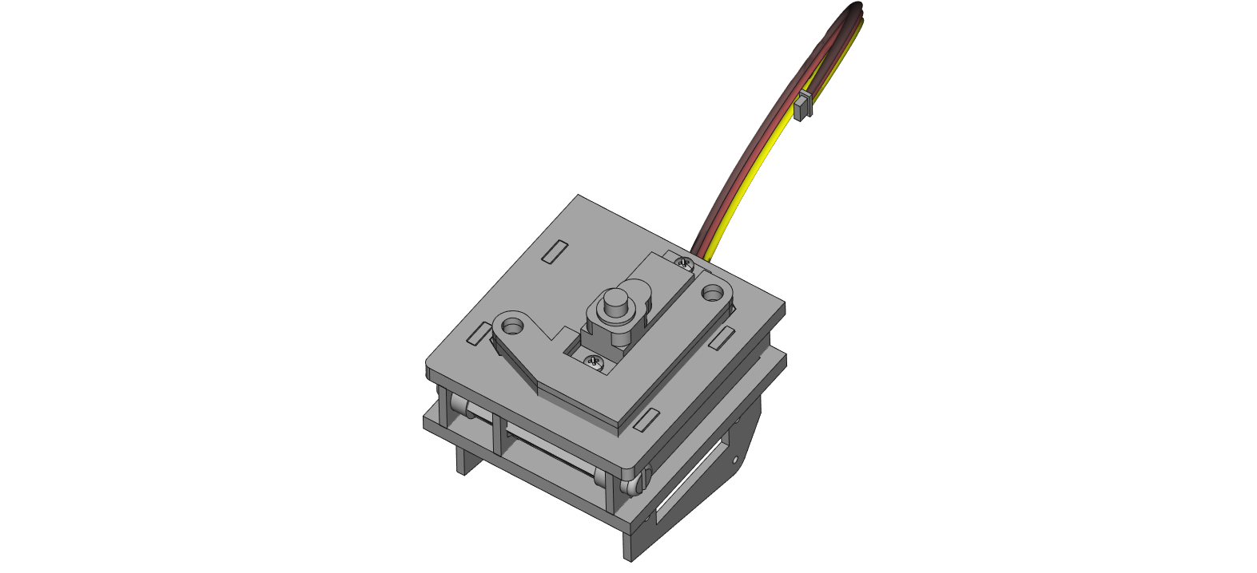

**STEP 10**: Place AB8 around AB6 and AB7 as shown. Hold in place.

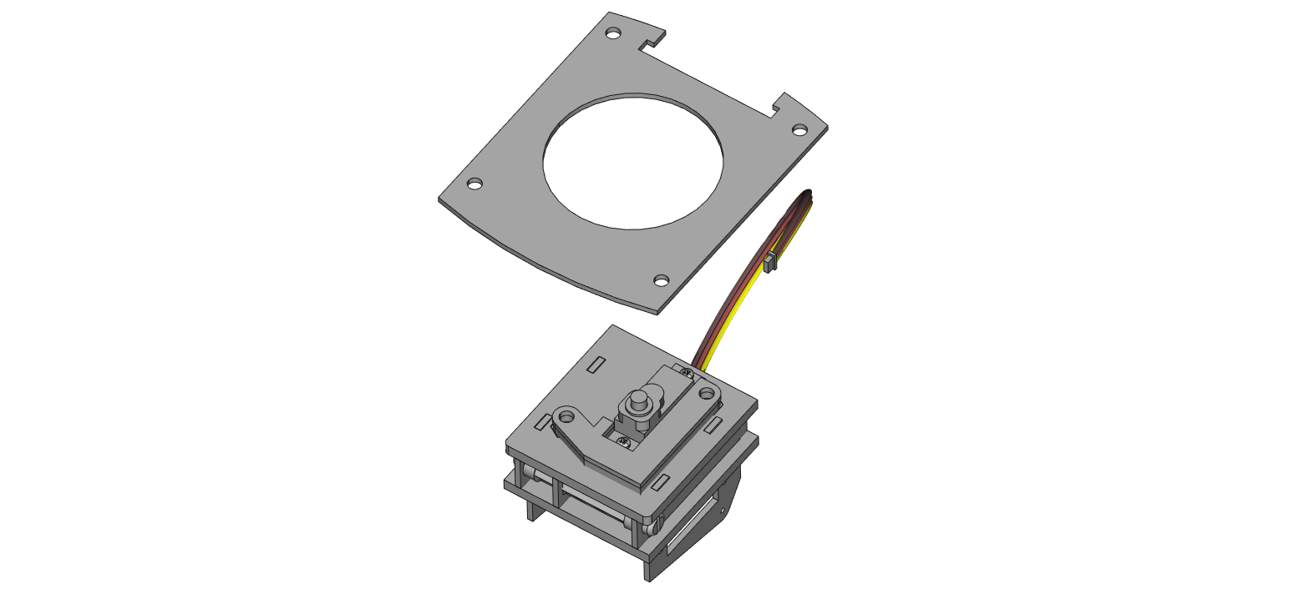

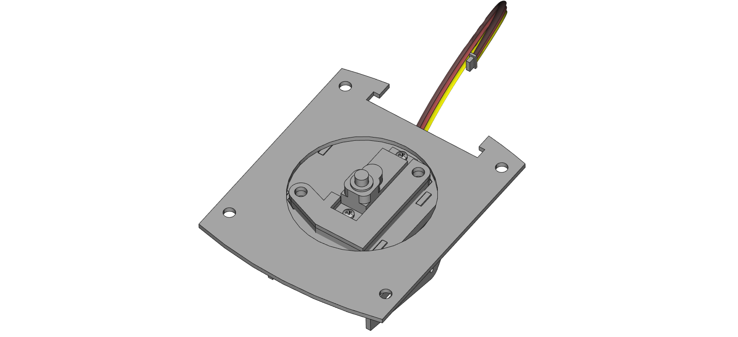

**STEP 11**: Place part AB9 onto the servo face that is highlighted.

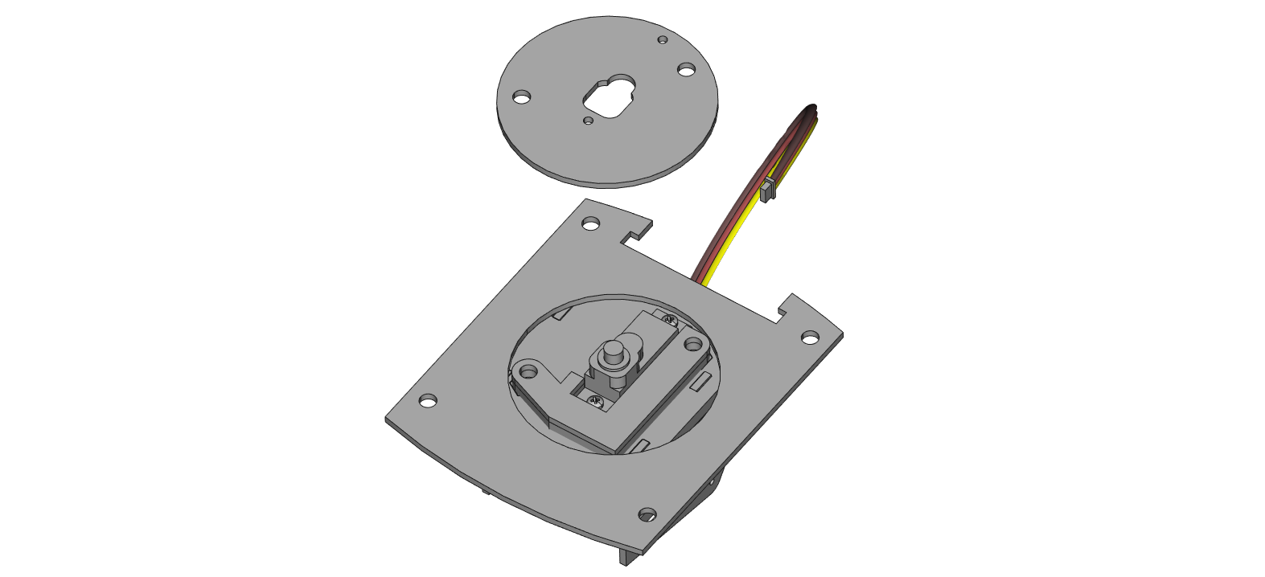

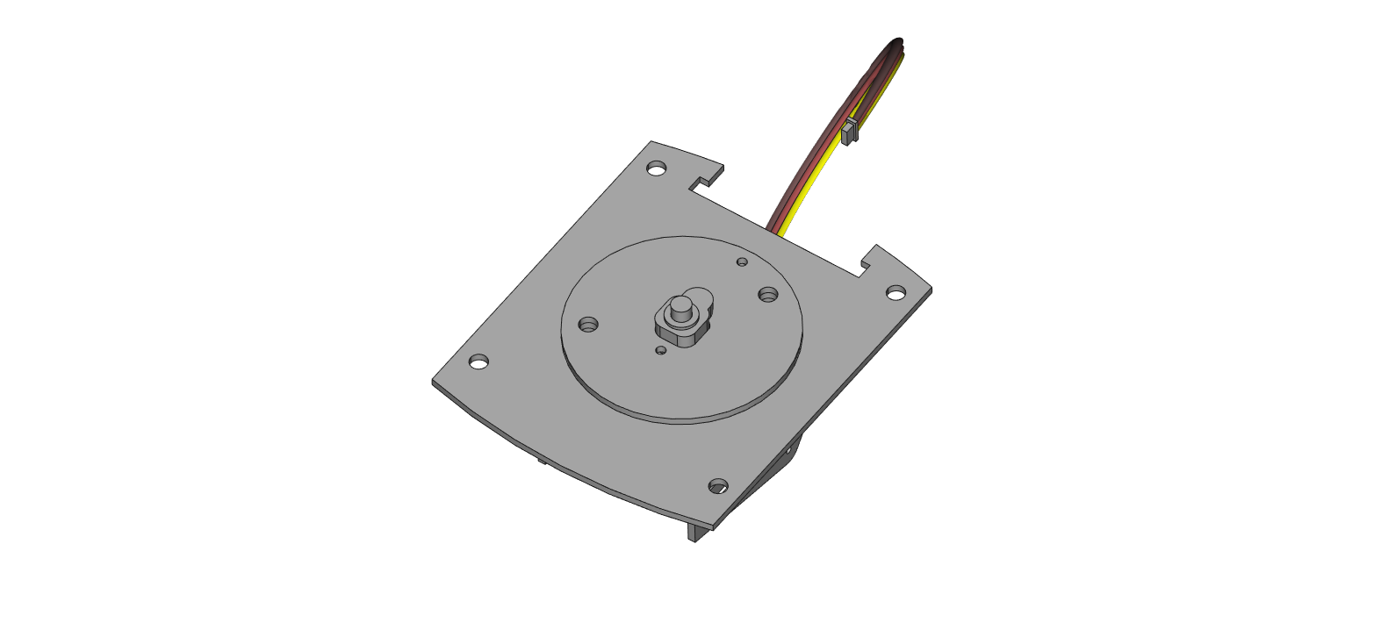

**STEP 12**: Make sure acrylic pieces are lined up by the holes. Insert 2 nylon screws through the stack into the 0.5” hex standoffs. Part AB8 will remain loose.

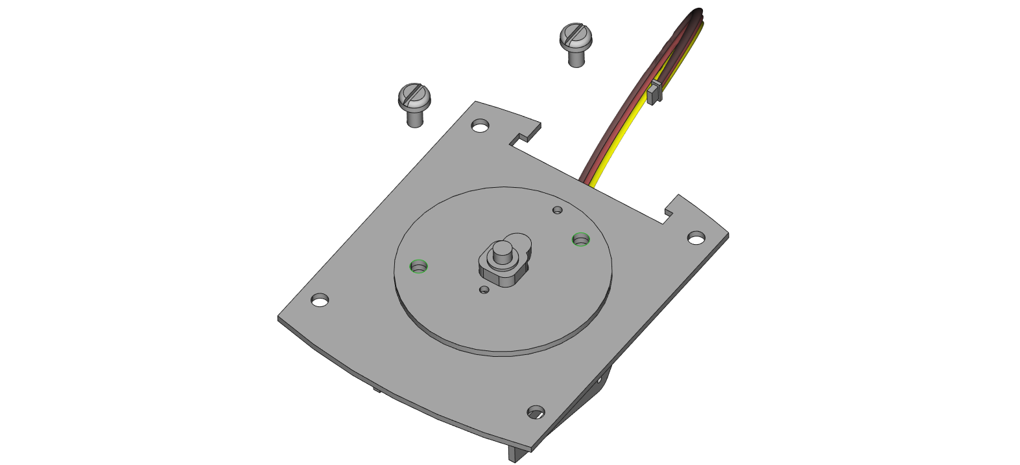

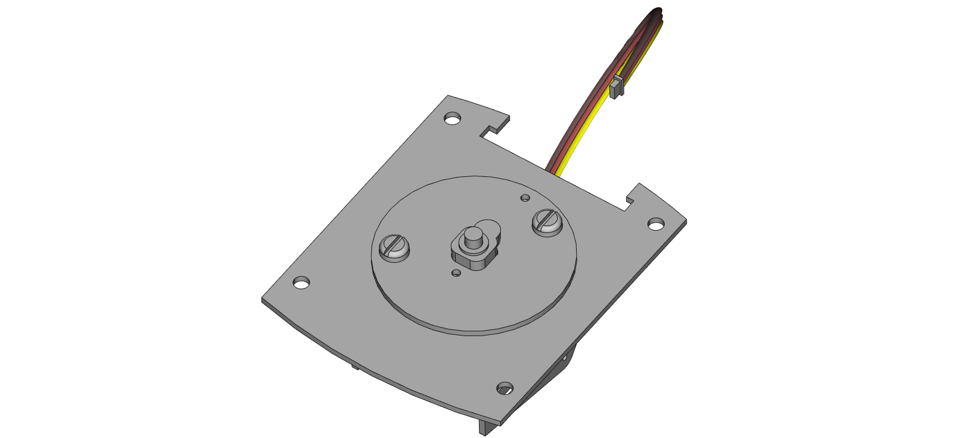

**STEP 13**: Carefully fit the servo output shaft into part A1, taking note of the matching grooves, and orientation of A1– the etched label should face the servo. Be careful not to turn the calibrated servo. Insert the servo with A1 attached through the rectangle opening on part AB3. Secure the servo with 2 large servo mounting screws and acrylic piece AB10.

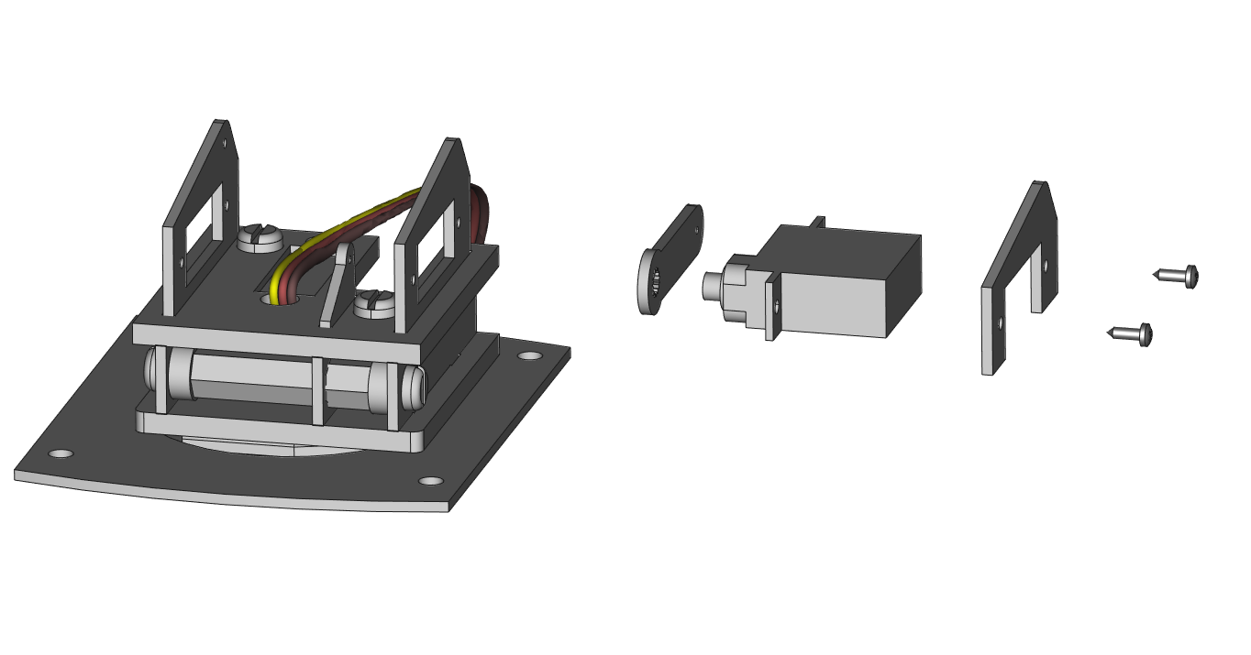

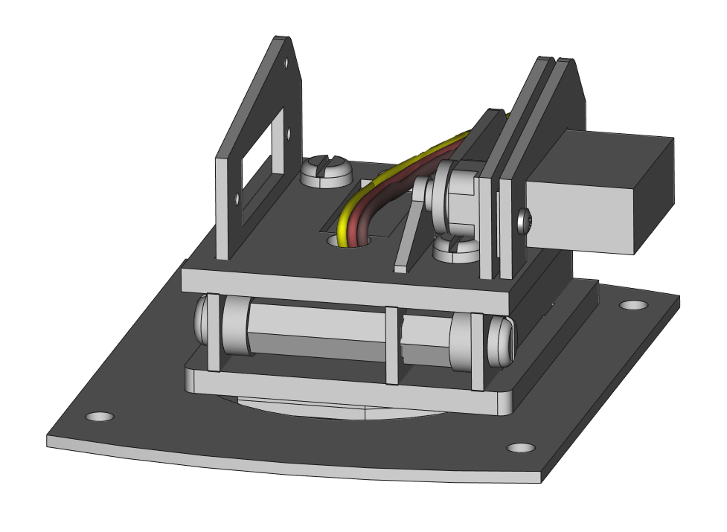

**STEP 14**: Take part A2 and mount it to part AB4 using 1 M1.4 x 8mm tapping screw. Keep AB4 perpendicular to the base. Thread screw through completely – the screw will appear too long for the hole, but the overhang can be trimmed off later if desired.

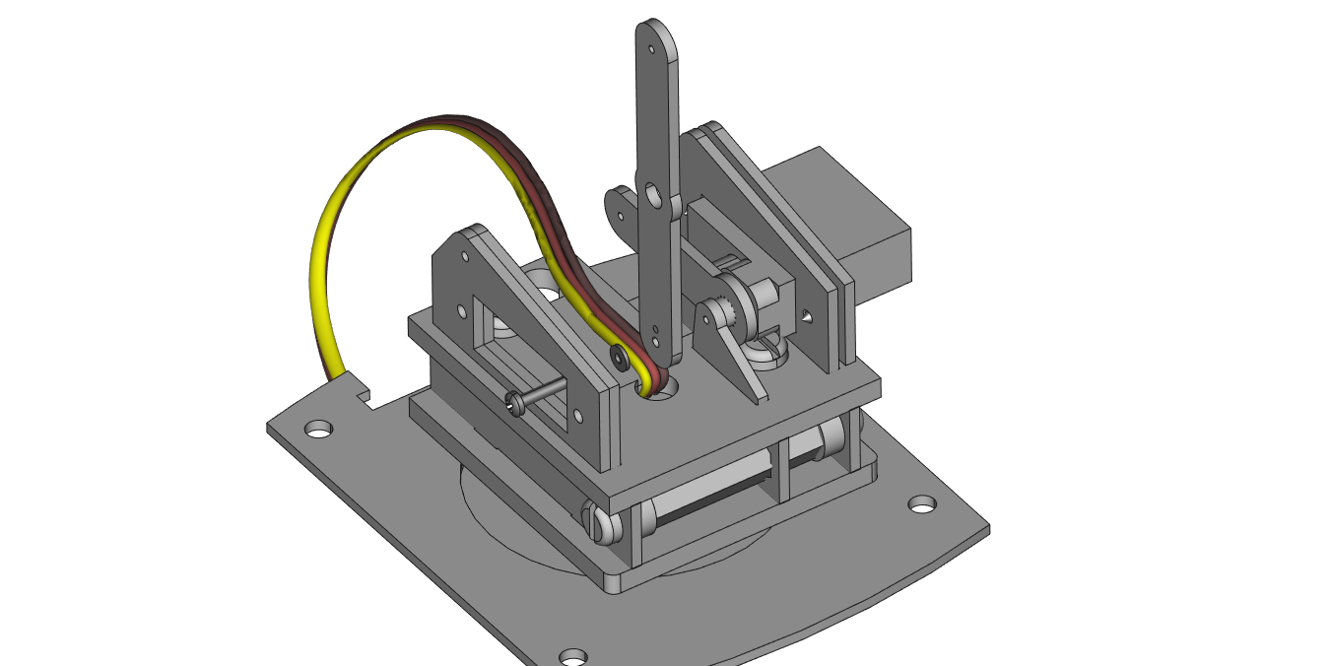

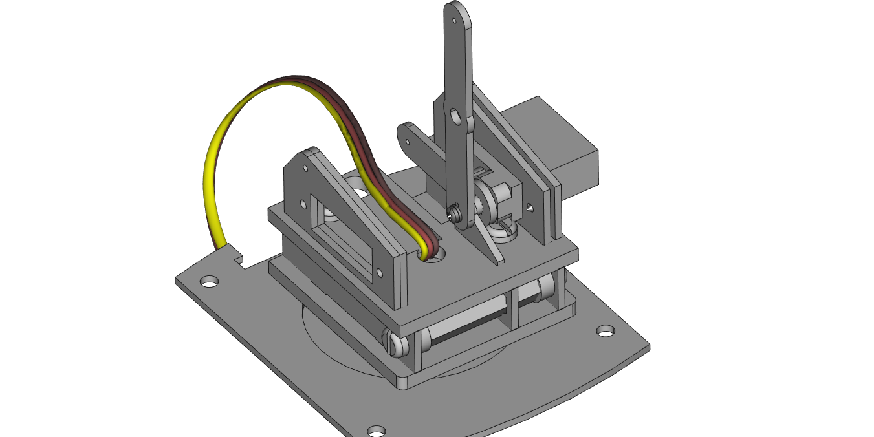

**STEP 15**: Take 1 servo and 2 more large servo mounting screws and mount the servo as shown using part AB11. Unlike the other side, AB11 goes in front of the servo. *NOTE: Make sure the servo has been calibrated and do not rotate it.*

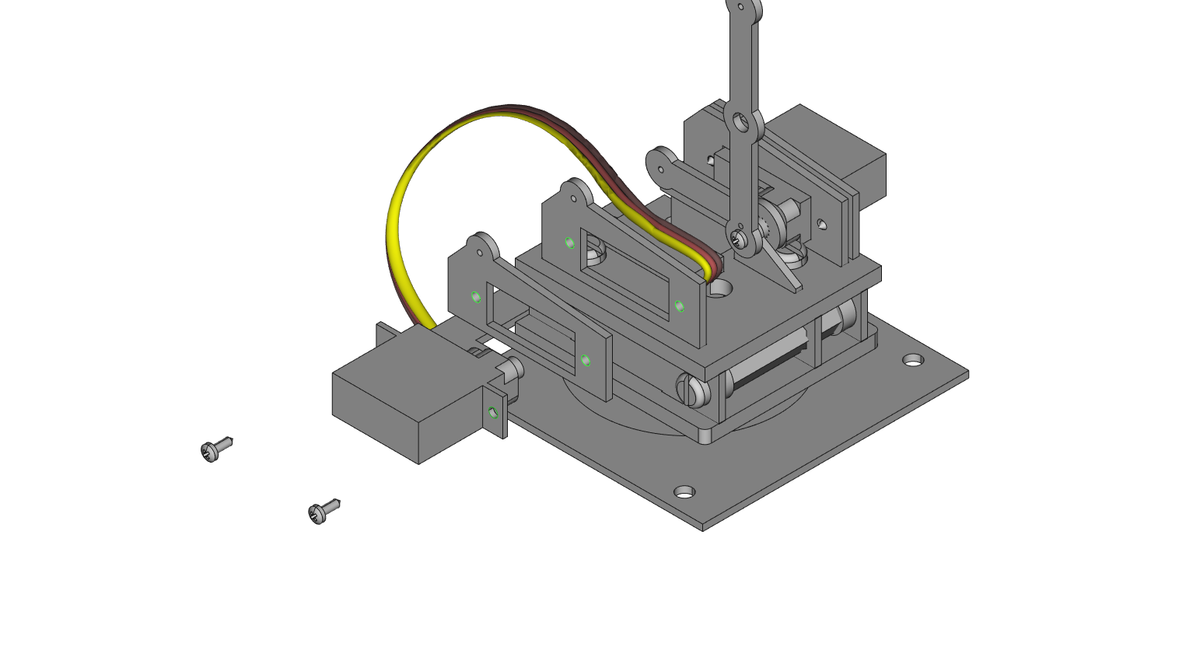

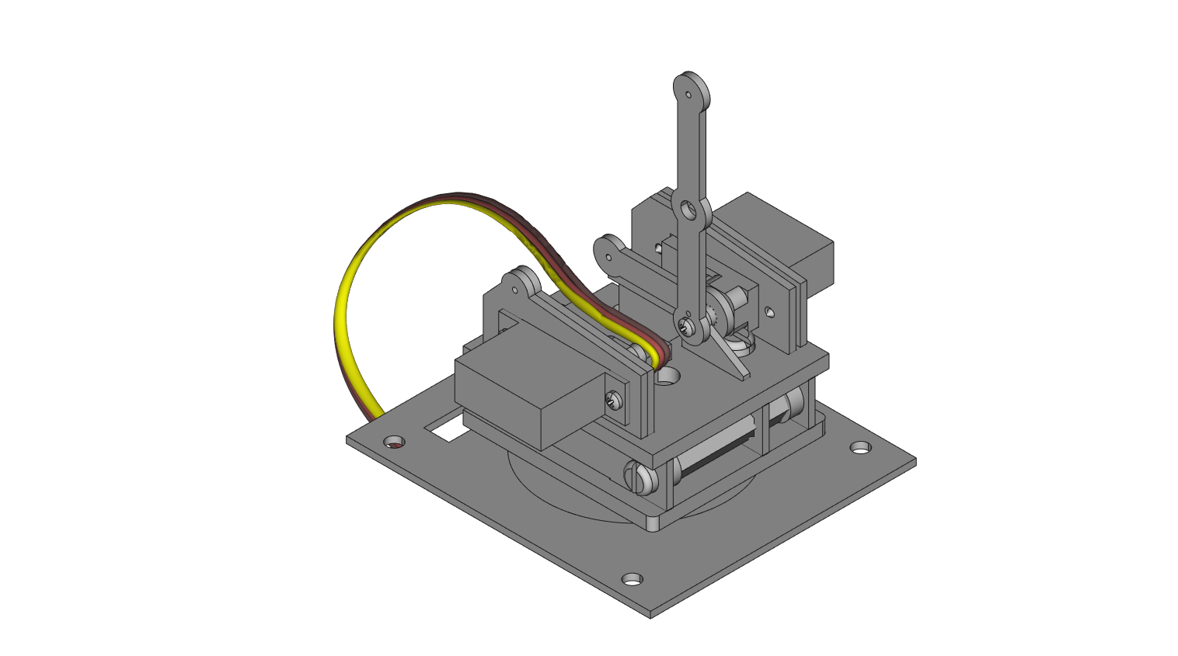

**STEP 16**: Push part A3 onto the shaft of the servo from the last step. Use even pressure around the servo gear to adhere part A3 without breaking the acrylic. Keep A3 perpendicular to the base to maintain the calibrated servos

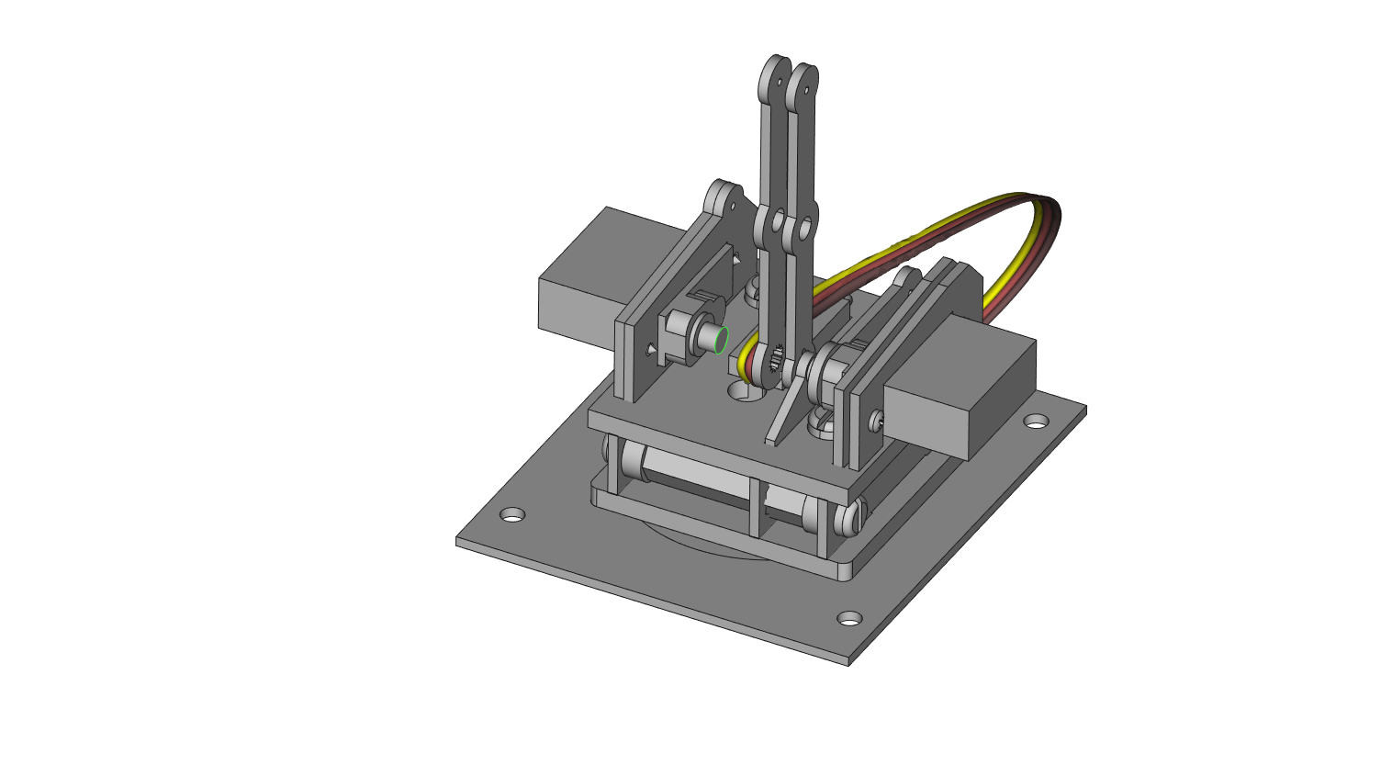

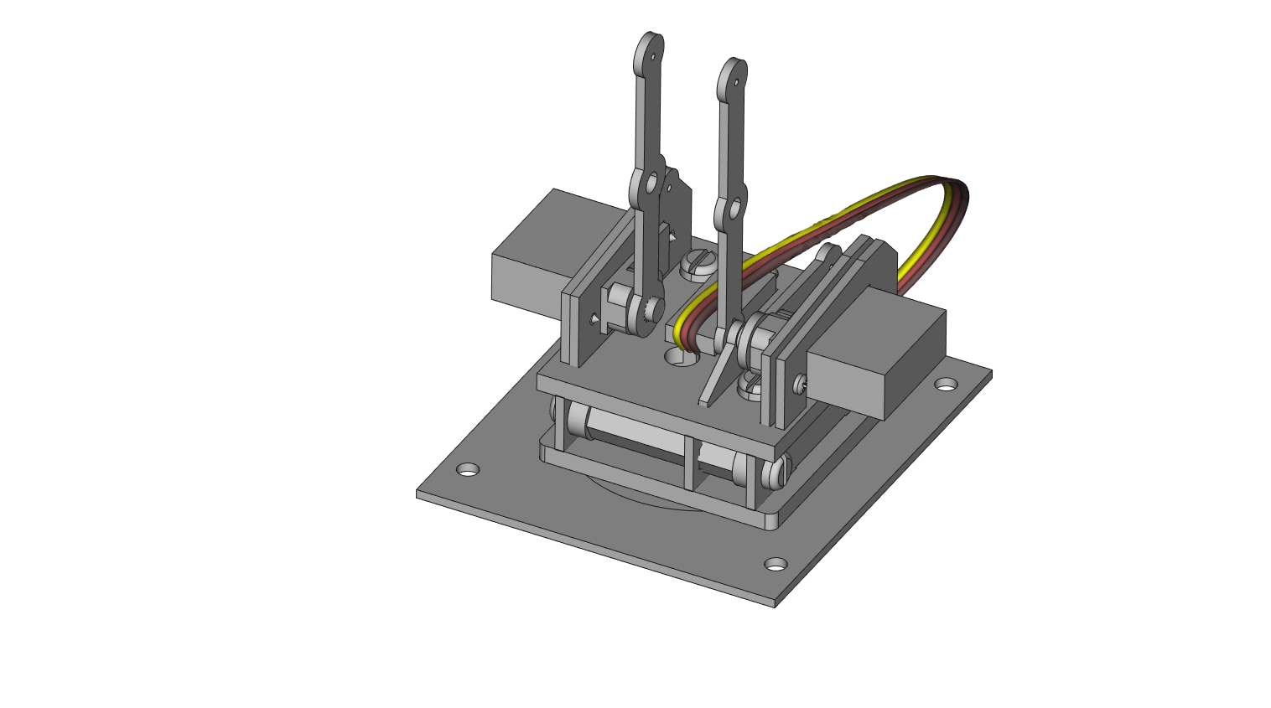

**STEP 17**: [OPTIONAL] This step only needs to be done if the arm piece pushed onto the servo shaft fits loosely. With 1 acrylic round part E, use 1 small servo head screw from any servo kit and mount part E to the end of the servo from the previous step. It may be necessary to loosen the screws on the servo to be able to get an angle to thread the screw.

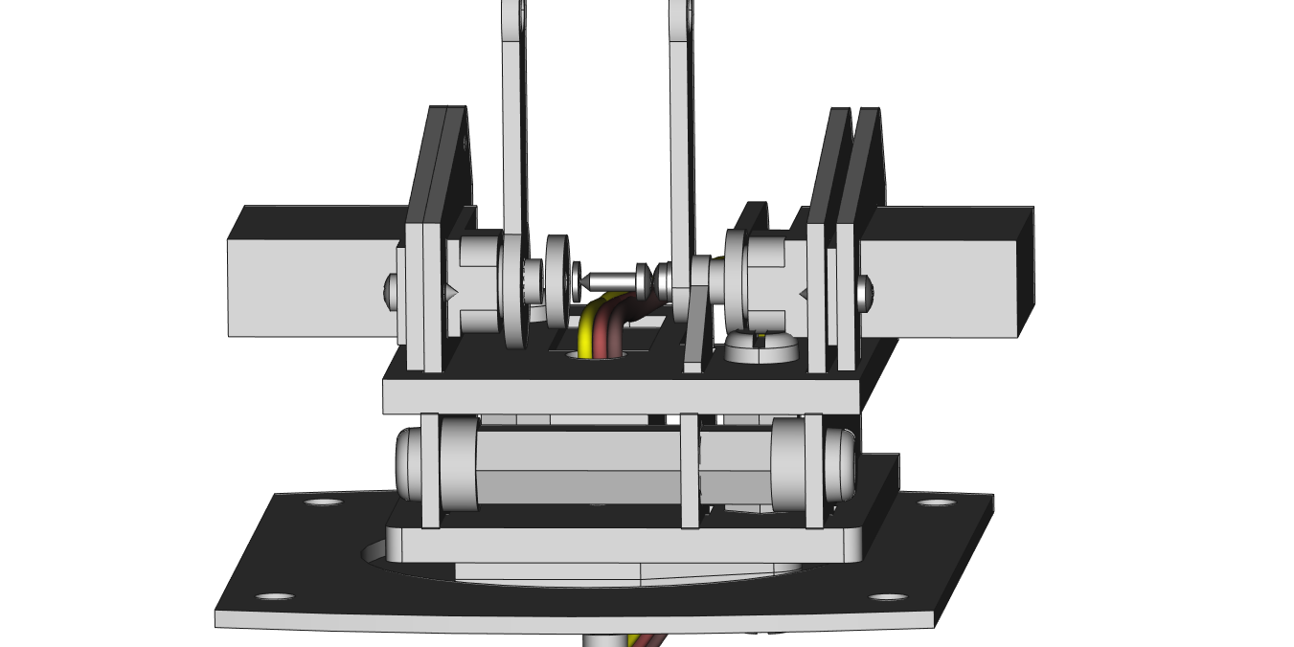

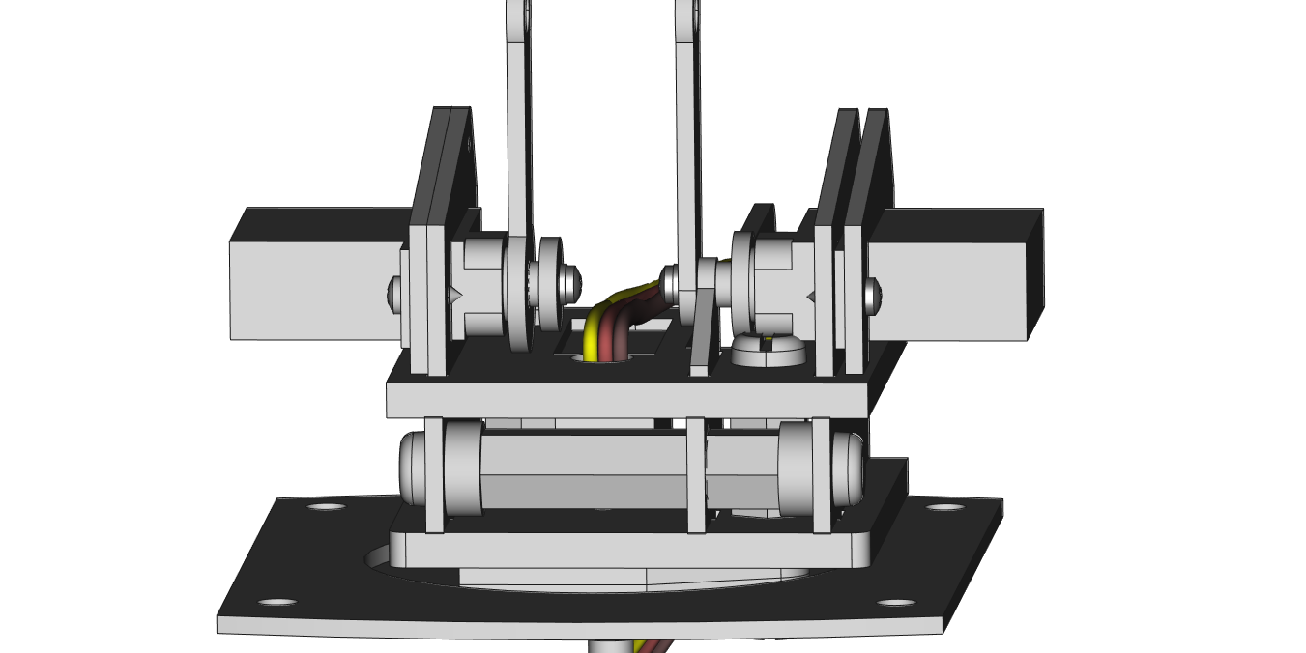

**STEP 18**: Mount A4 with 1 M1.4 x 8mm screw as shown. Pay close attention to the dot orientation on part A4.

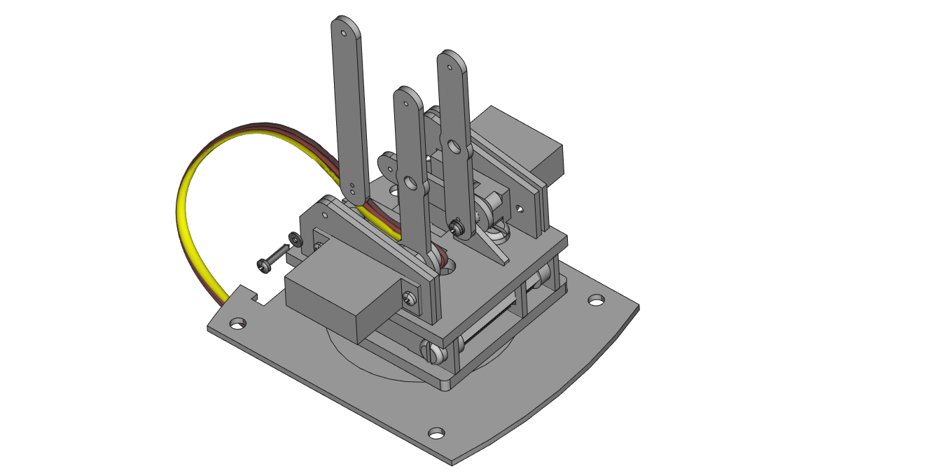

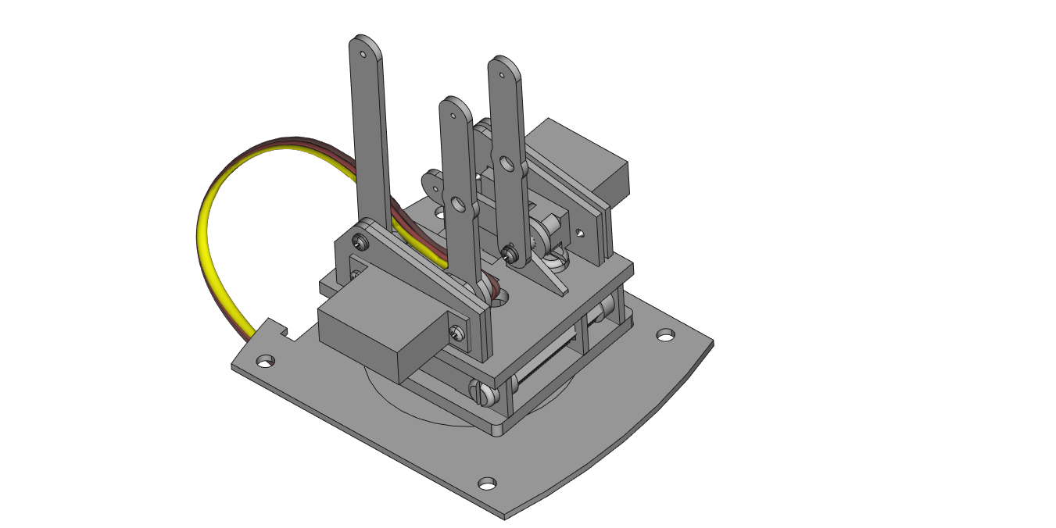

**STEP 19**: Mount part A5 as shown using 1 M1.4 x 8mm screw. Pay close attention to the dot orientation. Use 1 acrylic hex part E as shown to offset the screw – this way the screw will not scrape against part AB3. Be careful not to bend A1 when mounting A5.

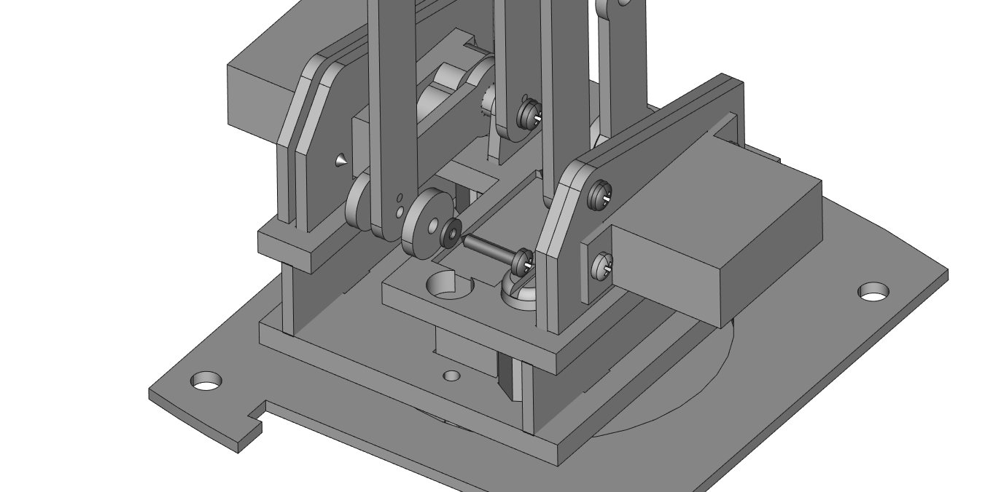

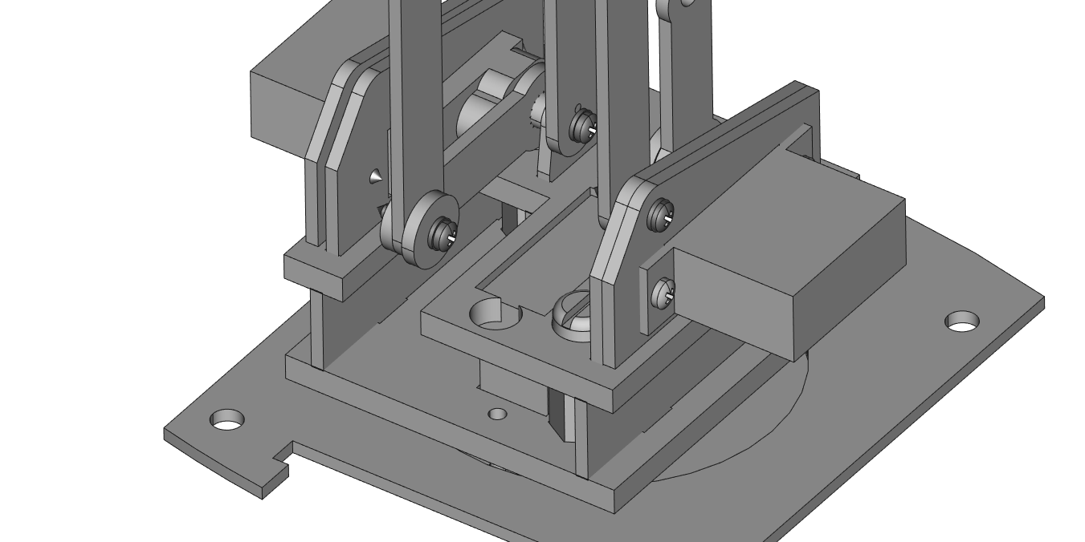

**STEP 20**: Between parts A2 and A3 use a 0.5” hex standoff and 2 thin acrylic washers/spacers on the outside of them. Thread 2 nylon screws into the spacer from either side.

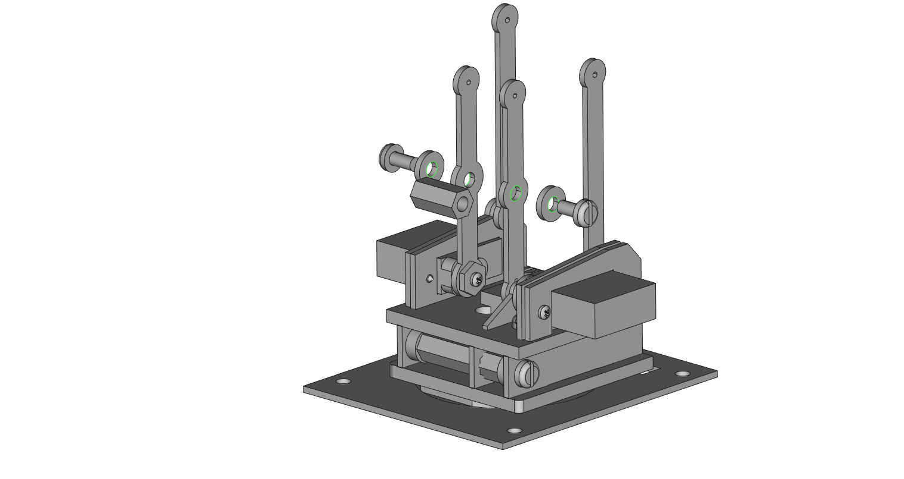

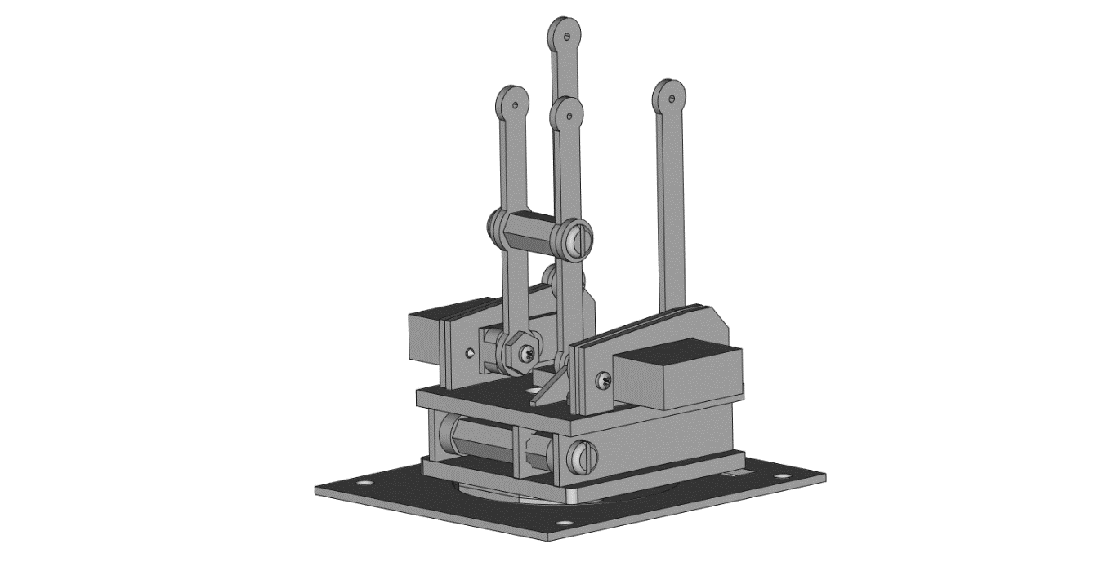

**STEP 21**: Mount junction part A6 and part A7 using 2 M1.4 x 8mm screws. Note the dot orientation on A6 and A7. Pay close attention to the second image in this step, as it most clearly shows the order the parts need to be mounted in.

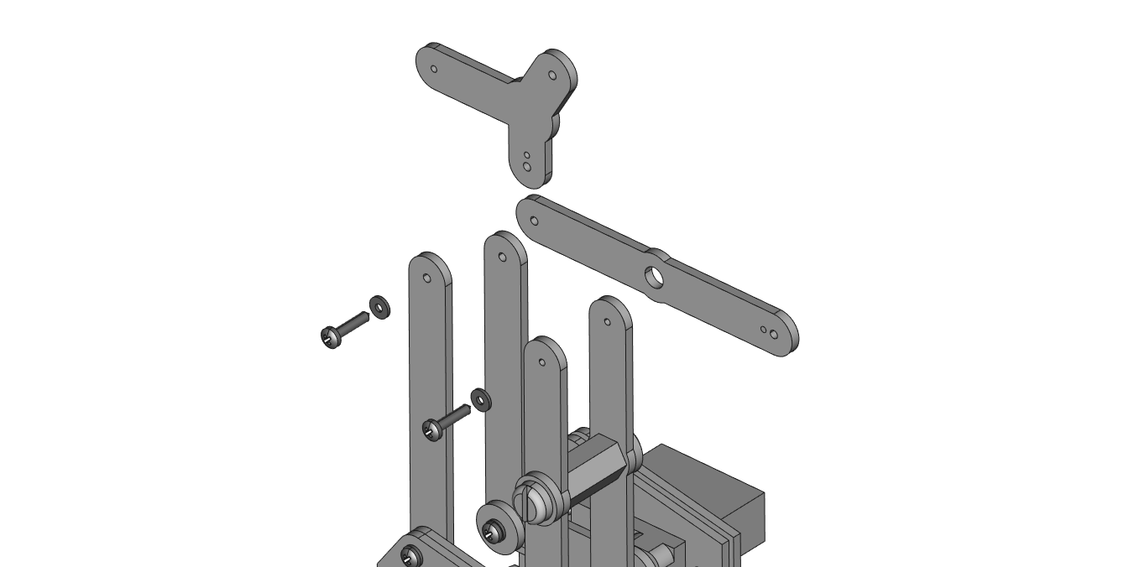

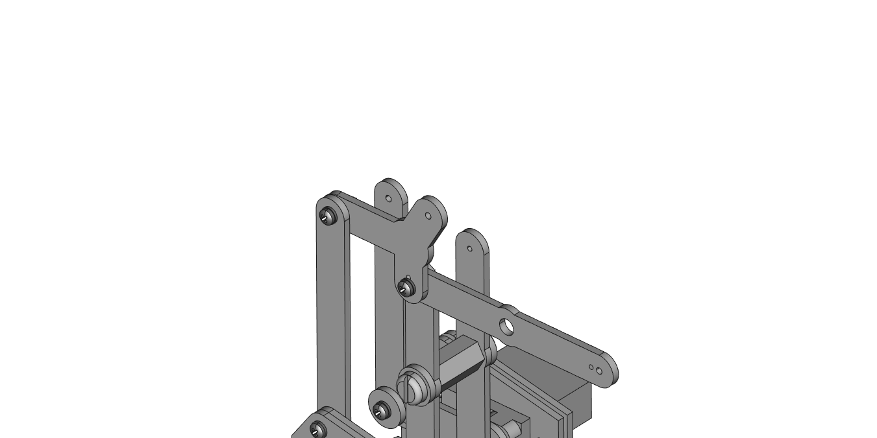

**STEP 22**: Mount A8 to A6 using 1 M1.4 x 8mm screw. Note the dot orientation on part A8.

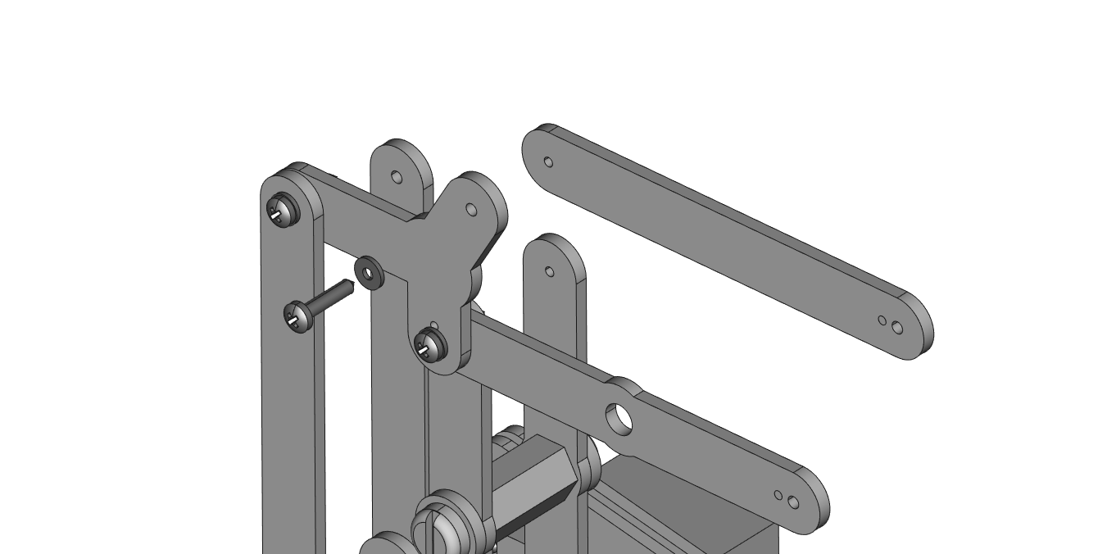

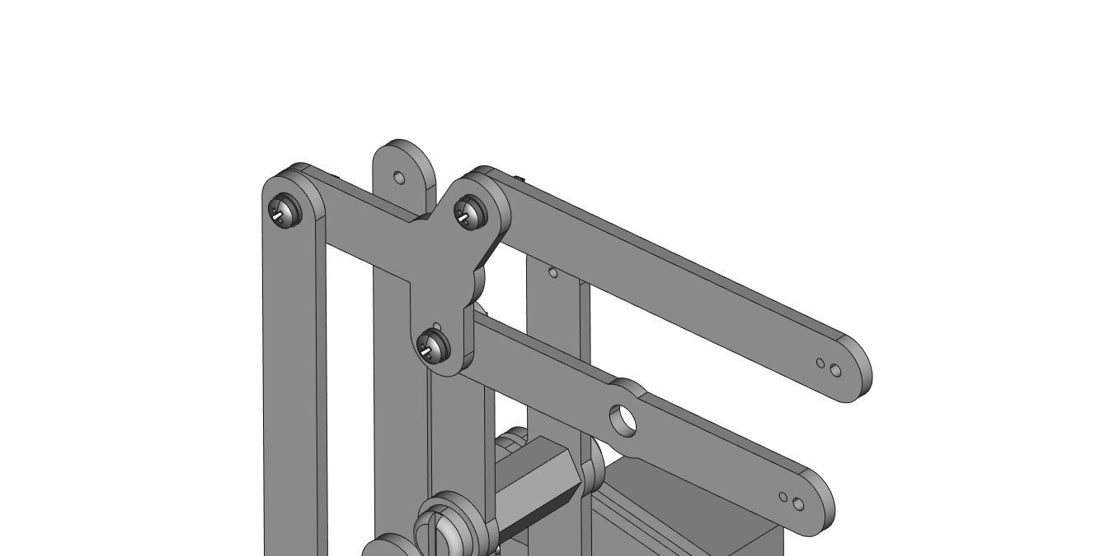

**STEP 23**: Mount A9 as shown using 2 M1.4 x 8mm screws. Note that A9 goes between the two vertical linkages/arm pieces.

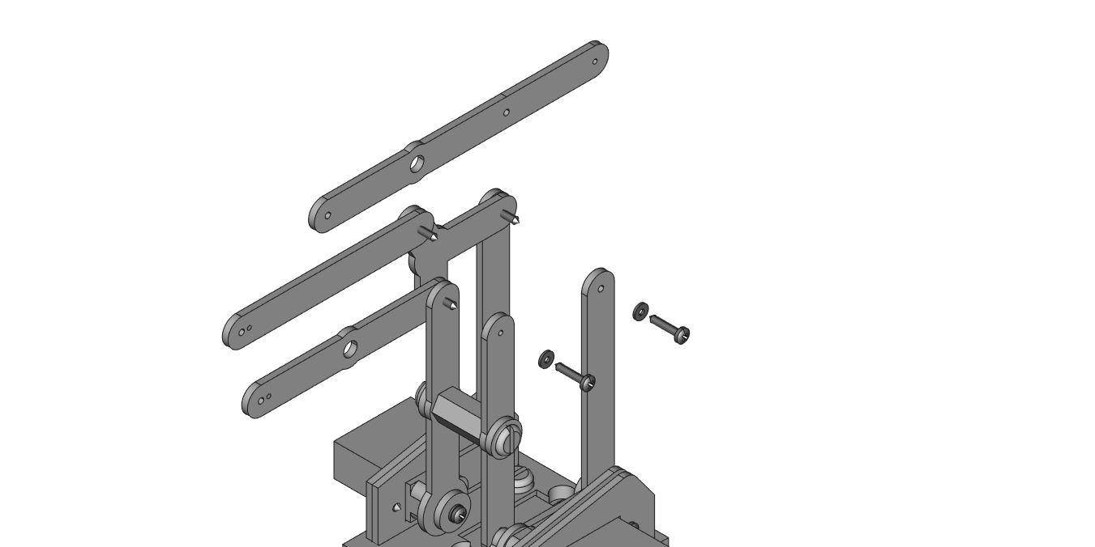

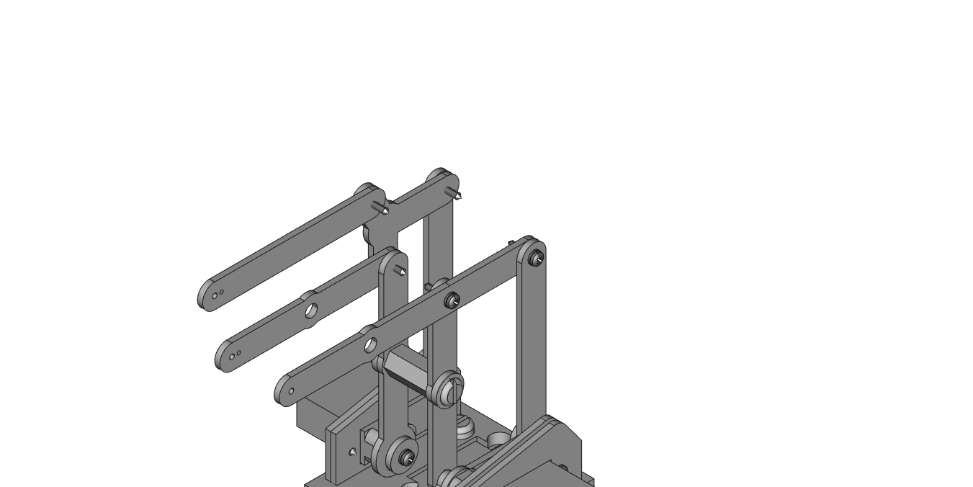

**STEP 24**: Take 1 white 0.5” hex standoff, 2 thin acrylic spacers, and 2 white nylon screws and secure the spacer in the arm as shown. *NOTE: The acrylic spacers are positioned inside the arm.*

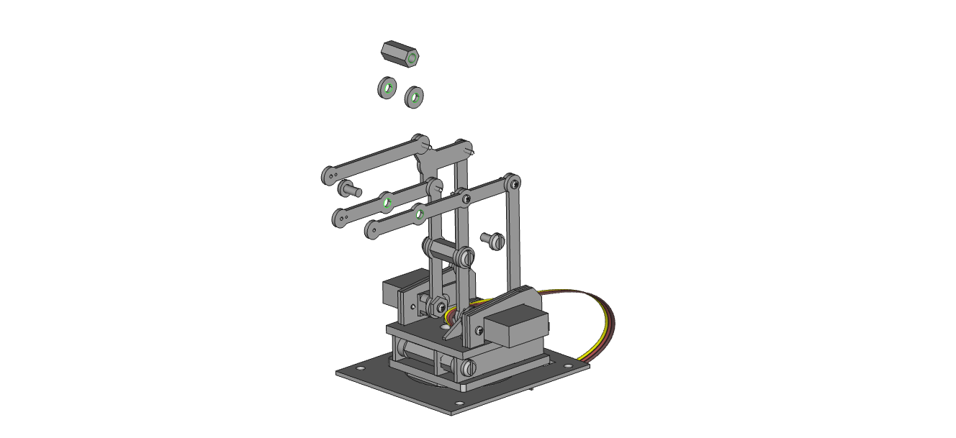

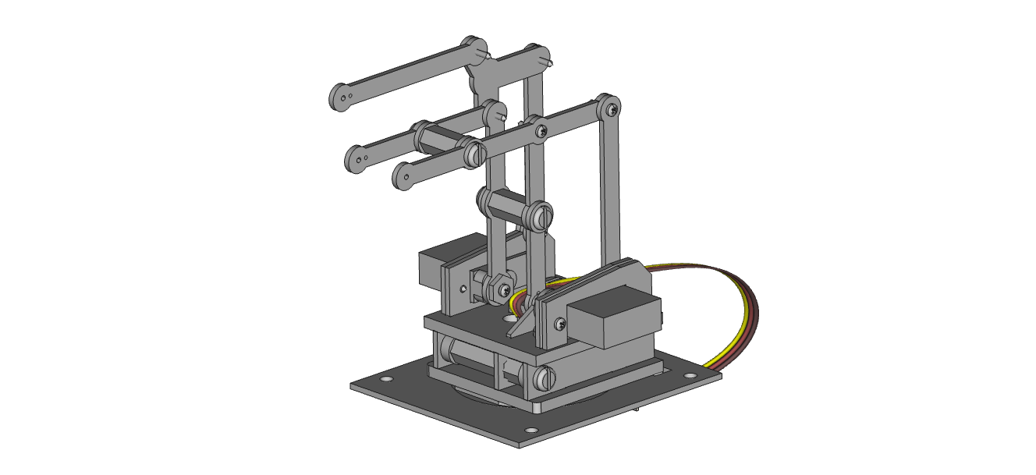

**STEP 25**: Set aside the car and arm assembly. Stack part CL2 on top of CL1 as shown and then mount 1 servo using 2 large servo mounting screws to part CL2. *NOTE: make sure the servo has been calibrated and be sure not to rotate it.*

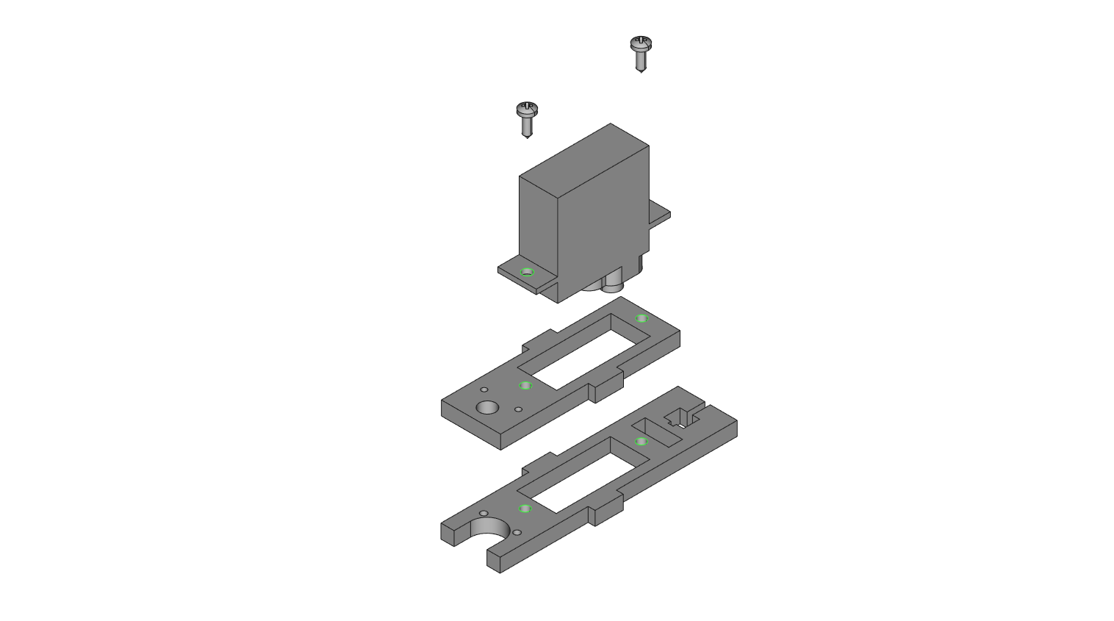

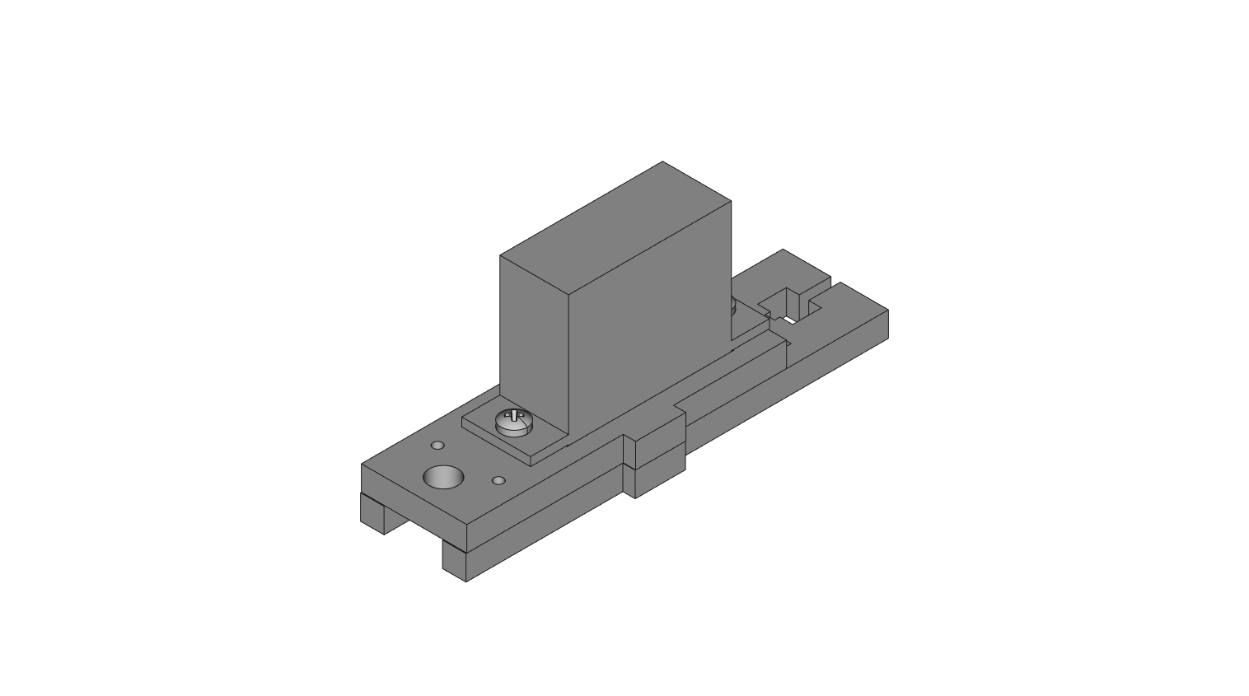

**STEP 26**: Attach 1 0.5” hex standoff to part CL2 using 1 nylon screw as shown.

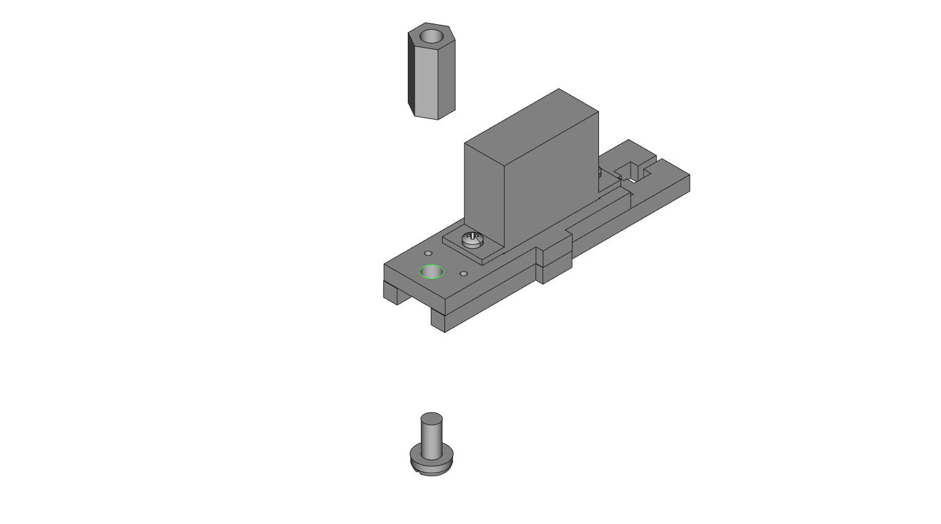

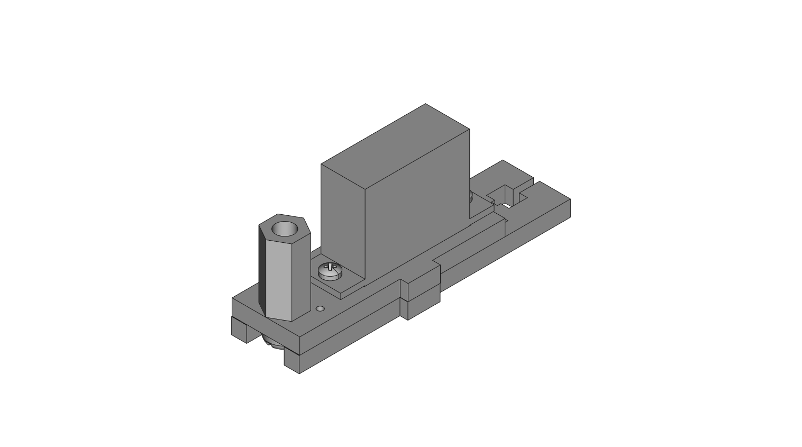

**STEP 27**: Attach 1 0.5” hex standoff to part CL3 using 1 white nylon screw. Offset the screw with a thin acrylic washer between the screw head and CL3 as shown.

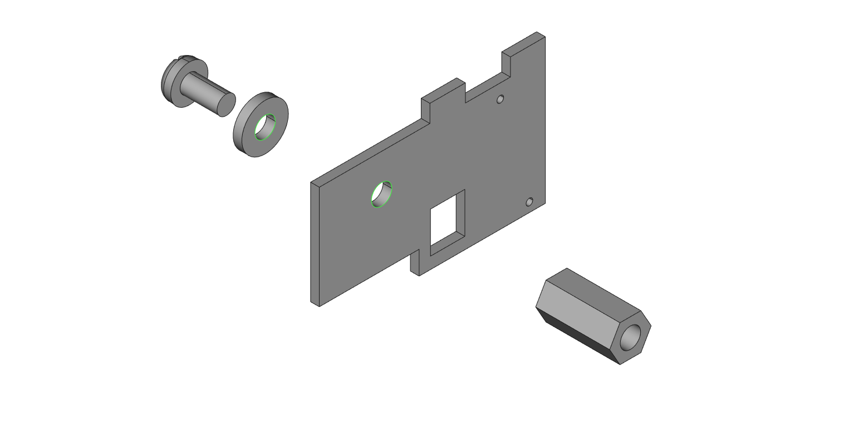

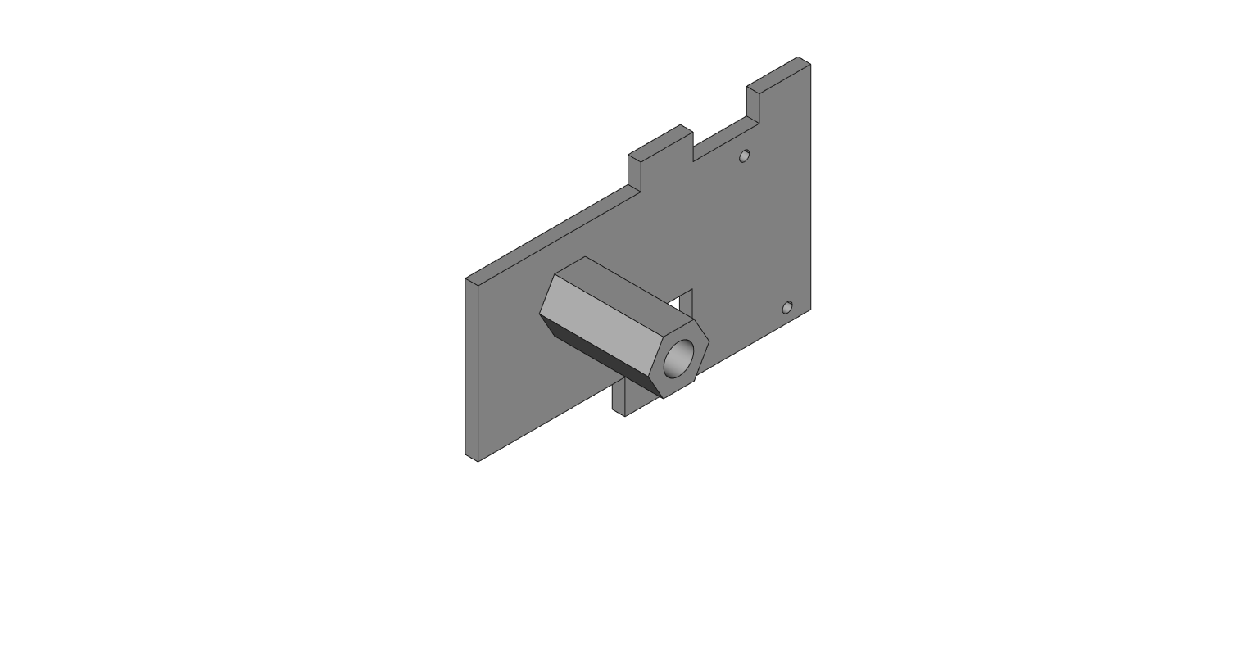

**STEP 28**: Take the assembly from the last step and part CL4 and use another thin acrylic spacer and 1 white nylon screw to attach the two plates together across parts CL1 and CL2.

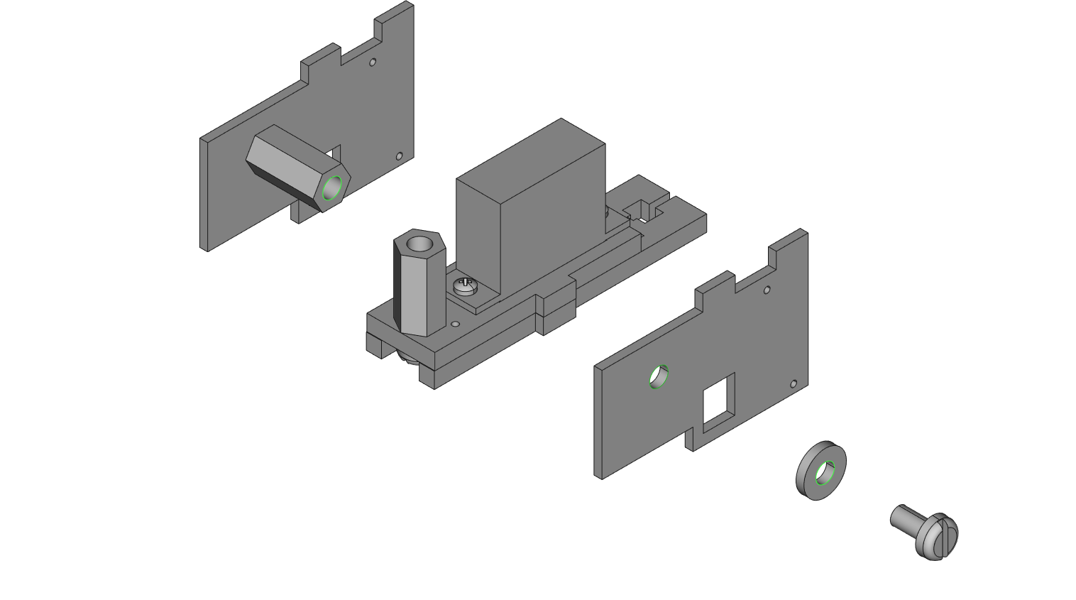

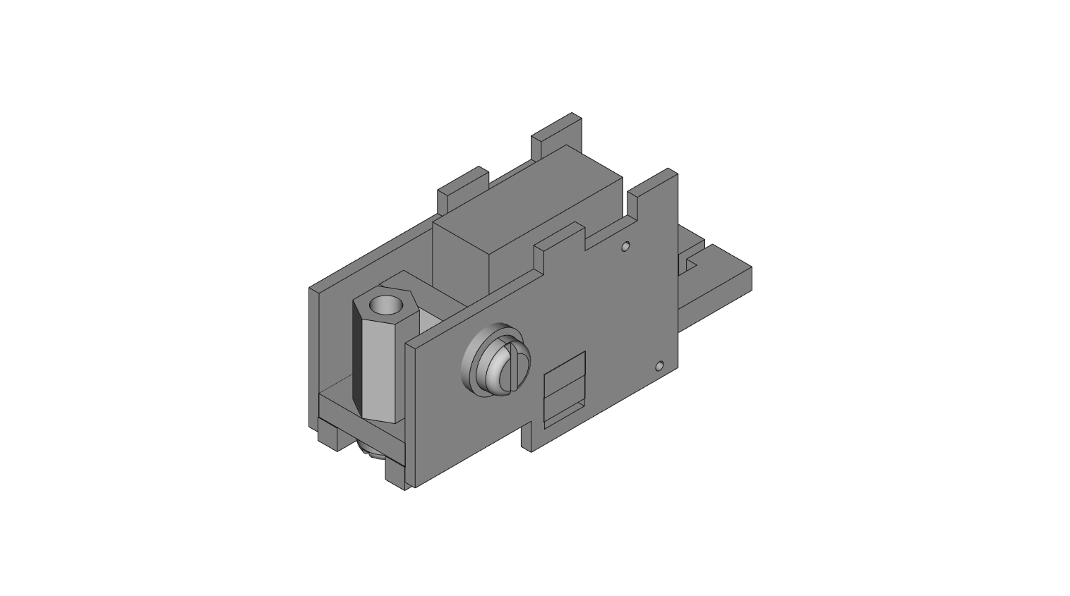

**STEP 29**: Slot the tabs on the tops of parts CL3 and CL4 into the new part CL5. Use 1 nylon screw through the highlighted hole into the vertical 0.5” hex standoff. The servo wire will hang out loosely here.

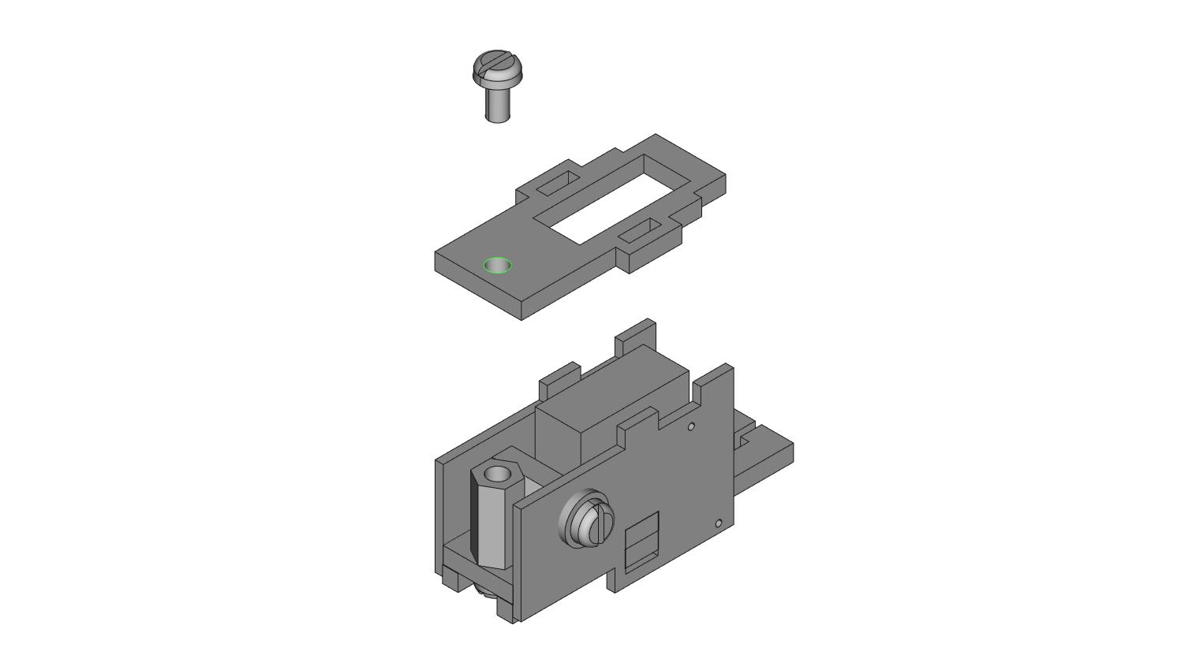

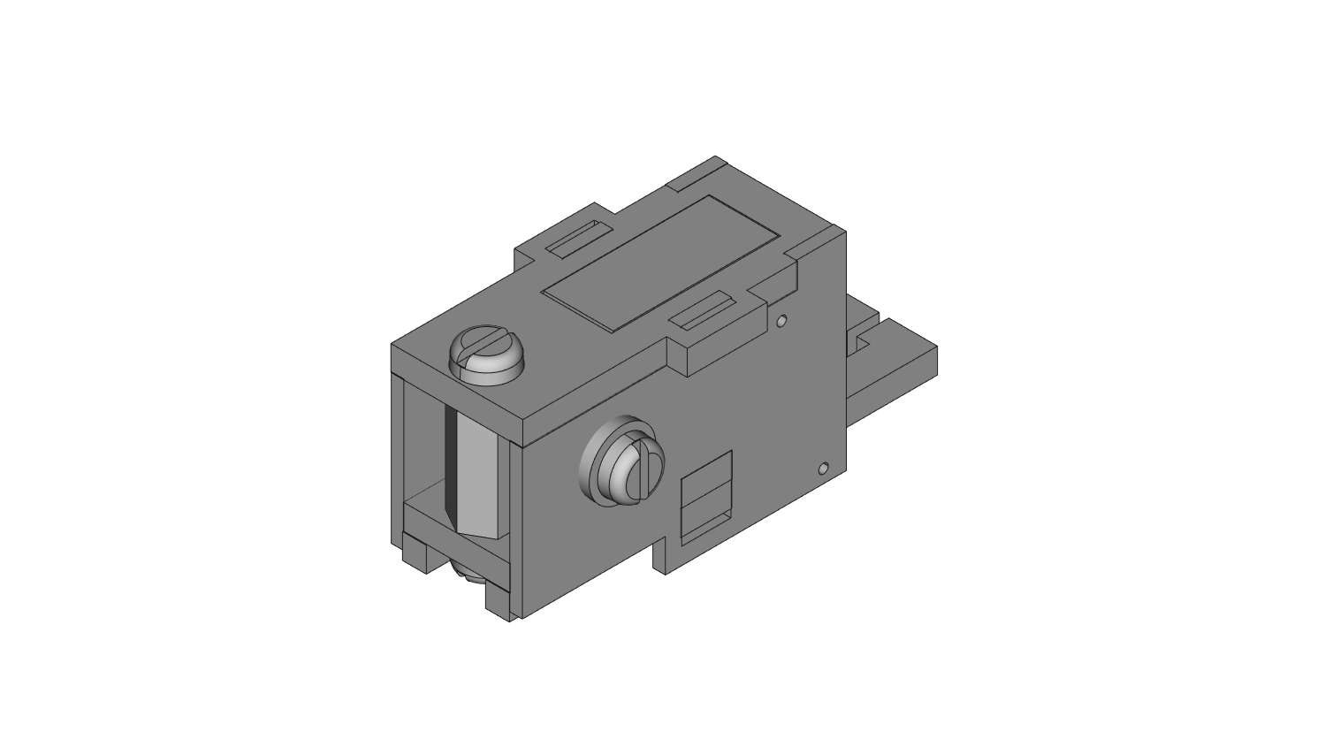

**STEP 30**: Attach claw piece CL6 to the bottom of CL1 using 1 M1.4 x 8mm screw. The initial position of the claw should be closed as shown.

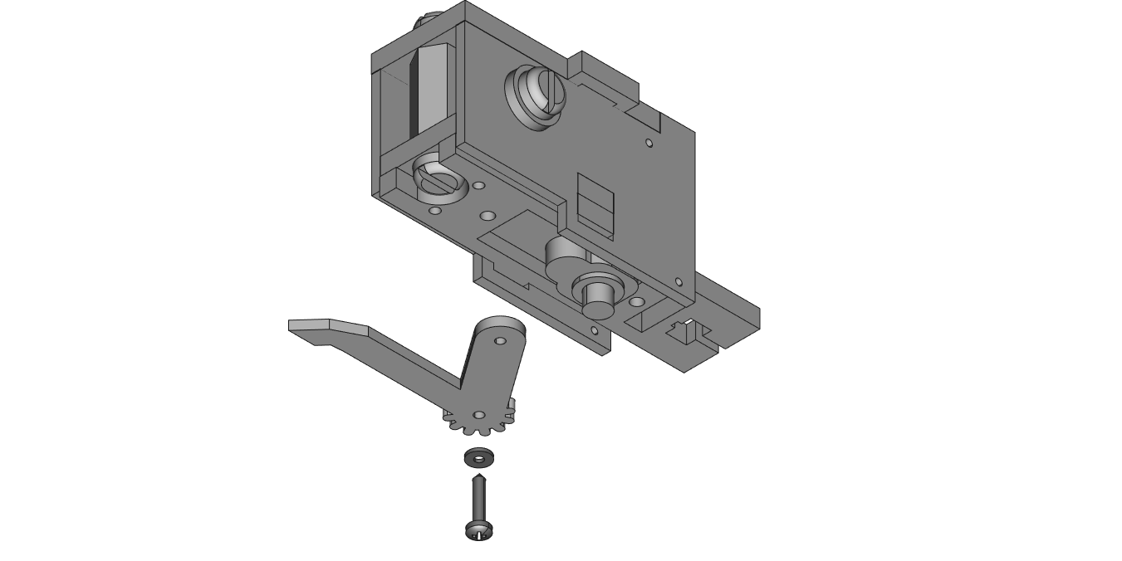

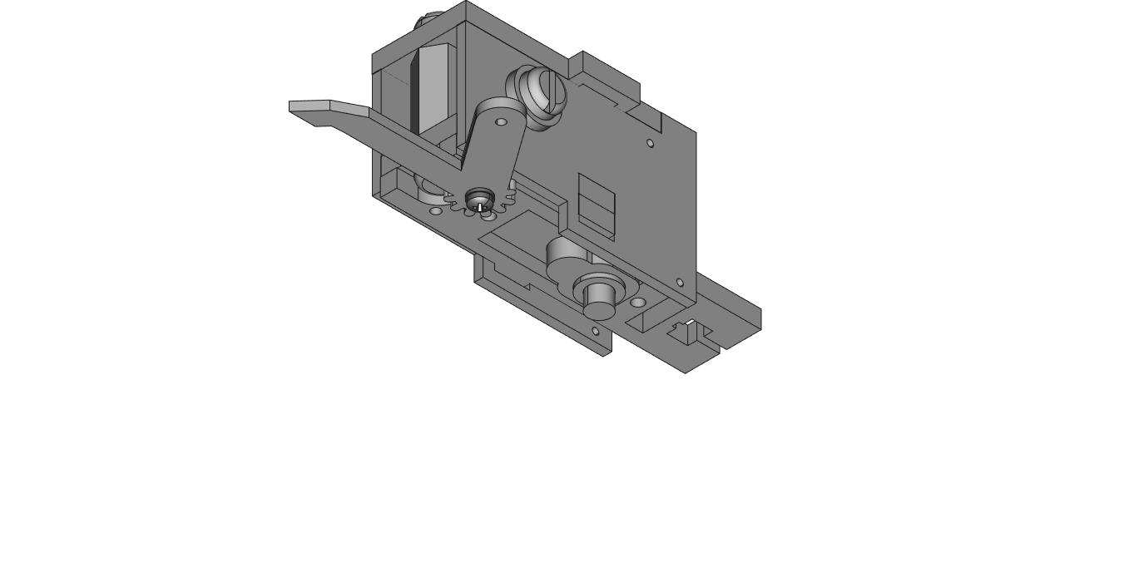

**STEP 31**: Attach part CL7 to CL1 using 1 M1.4 x 8mm screw. The initial claw position should be closed, and lined up with CL6.

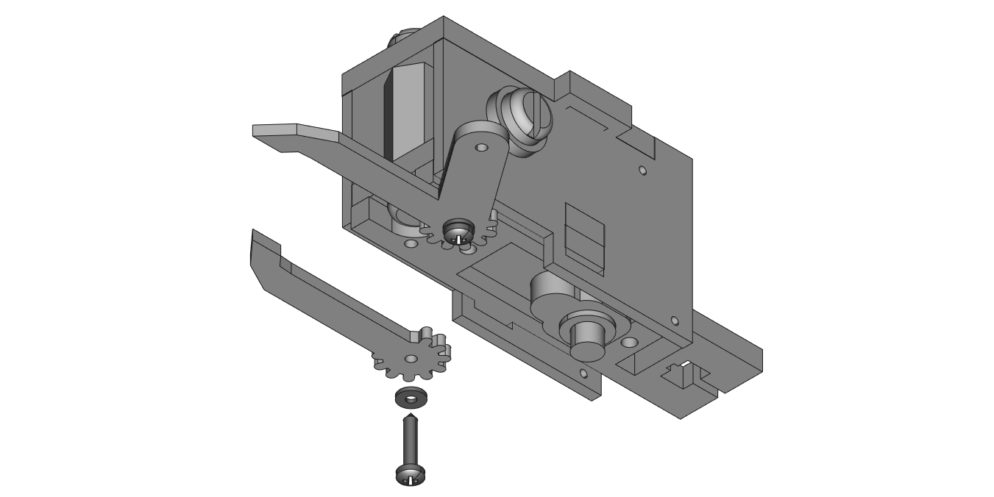

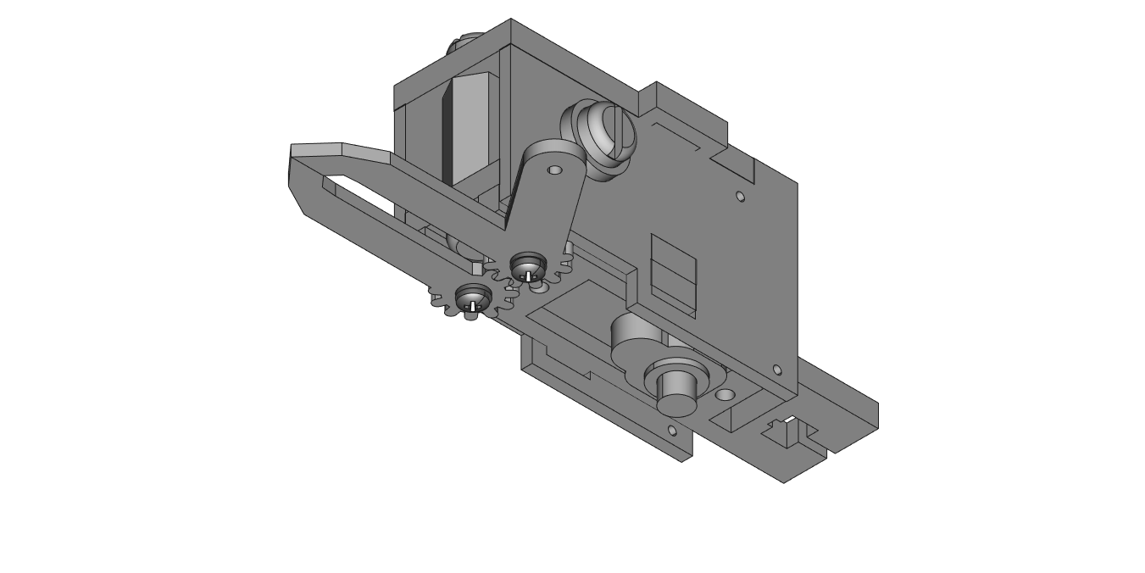

**STEP 32**: Take part CL8 and mount it to the bottom face of arm on CL6 using 1 M1.4 x 8mm screw.

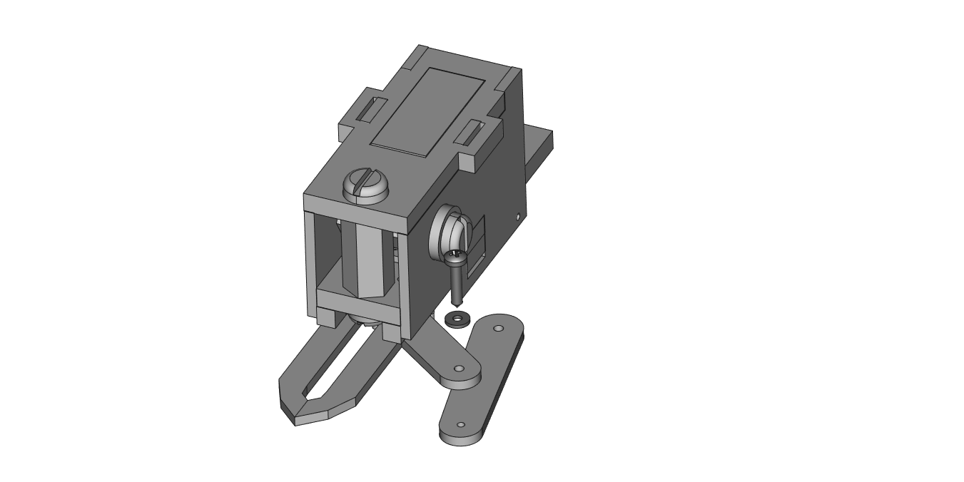

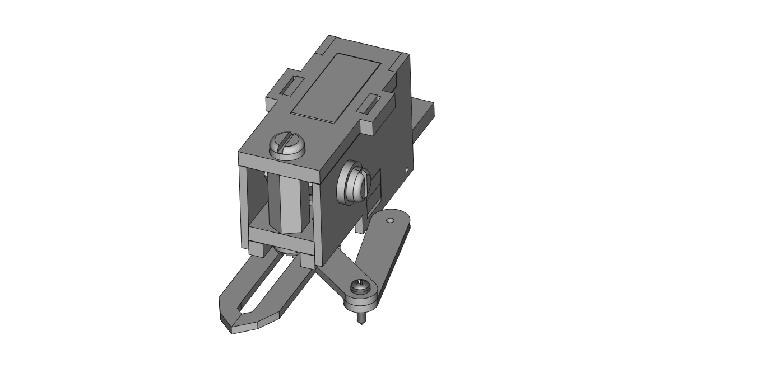

**STEP 33**: From the bottom, push CL9 onto the servo shaft of the claw so that it lines up with part CL8. *[OPTIONAL] The end plate for the servo (part E) can be screwed onto the shaft of the claw servo using 1 small servo head screw.*

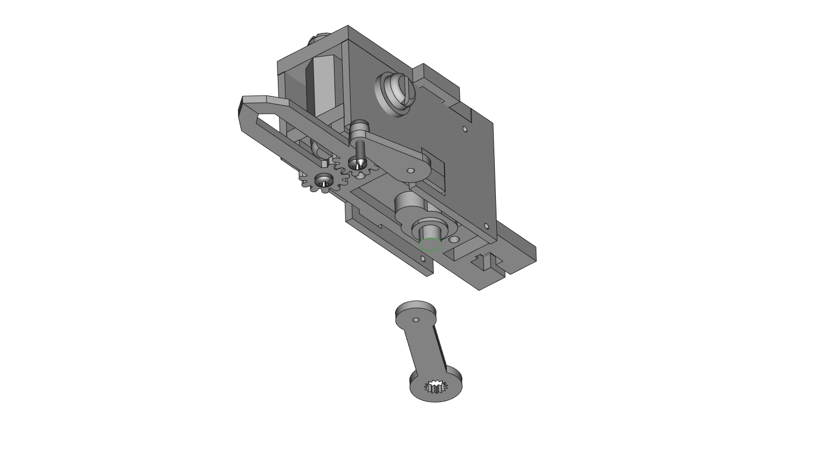

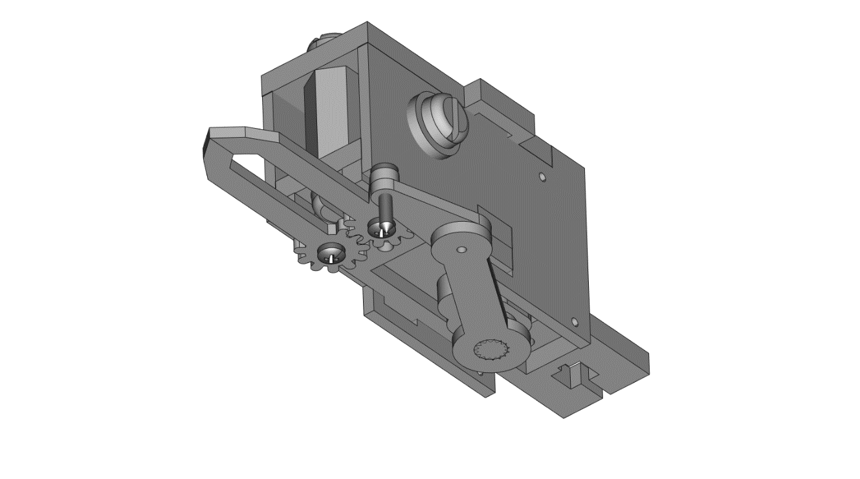

**STEP 34**: Thread 1 M1.4 x 8mm screw through both CL9 and CL8.

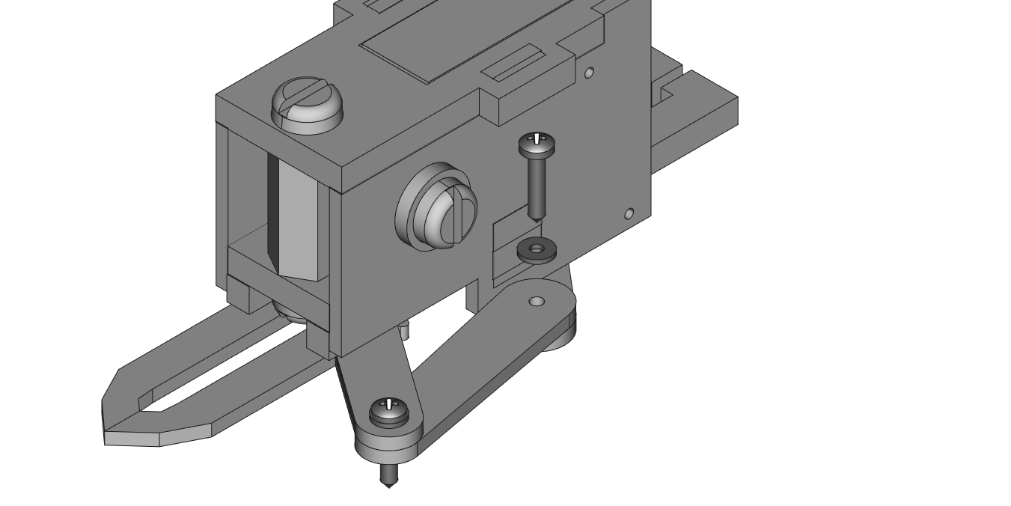

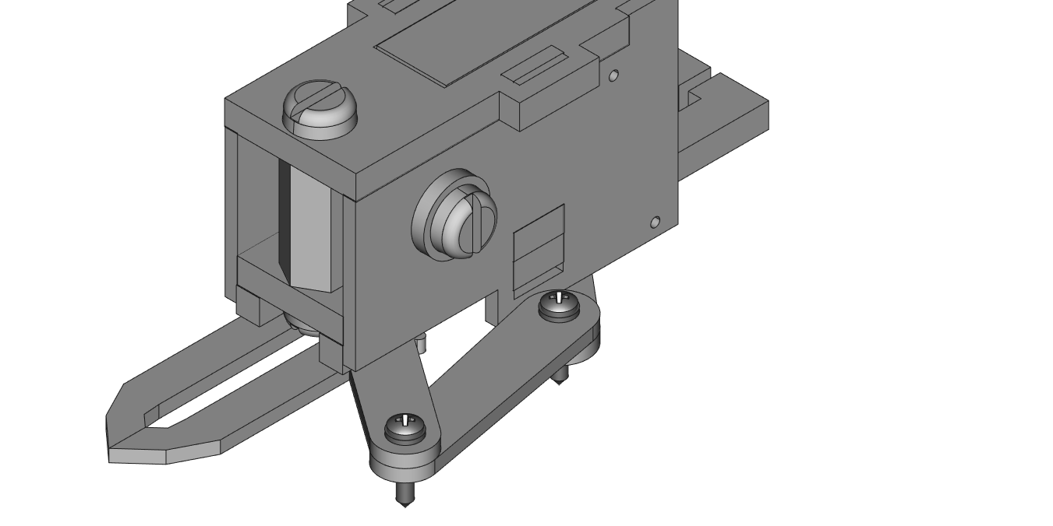

**STEP 35**: From left to right, thread 2 M1.4 x 8mm screws through the TOF Distance Wireling, part CL10, and then part CL11.

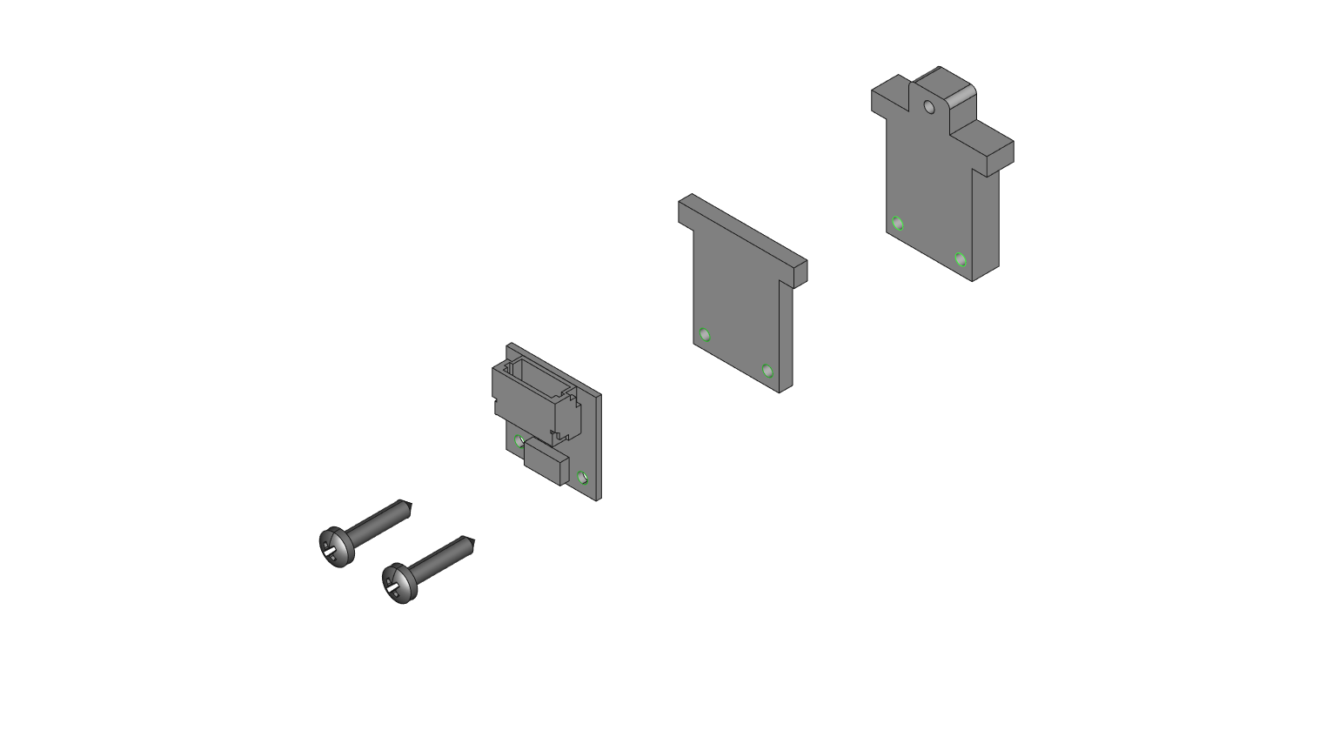

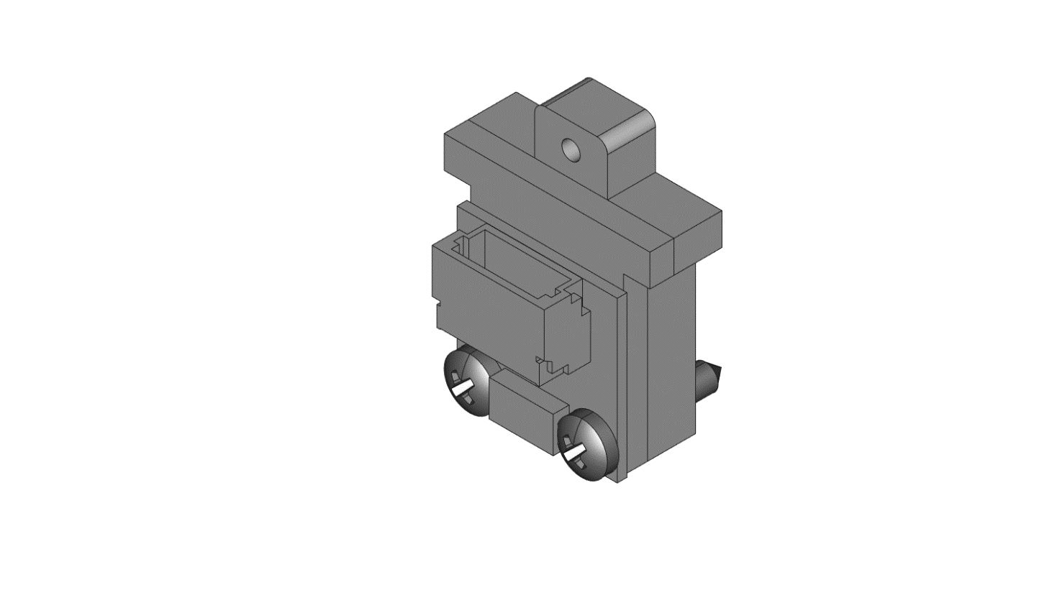

**STEP 36**: Plug in 1 200mm 5-pin black Wireling wire into the TOF sensor and thread it through the slot on CL2 as already shown. At the same time, push the top of CL11 into the smaller back slot.

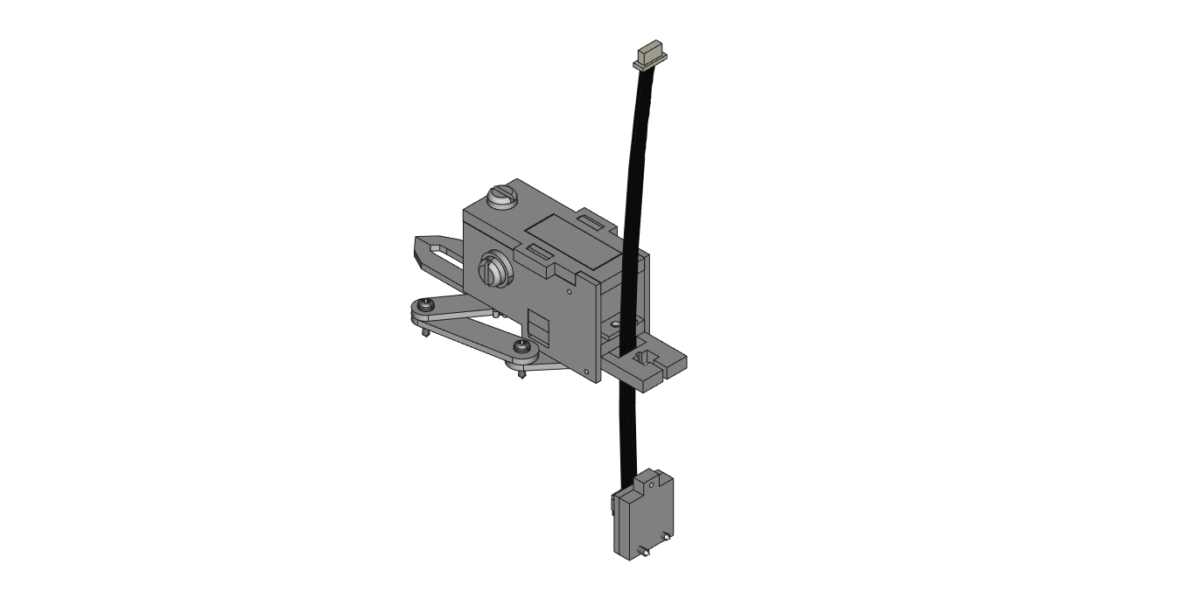

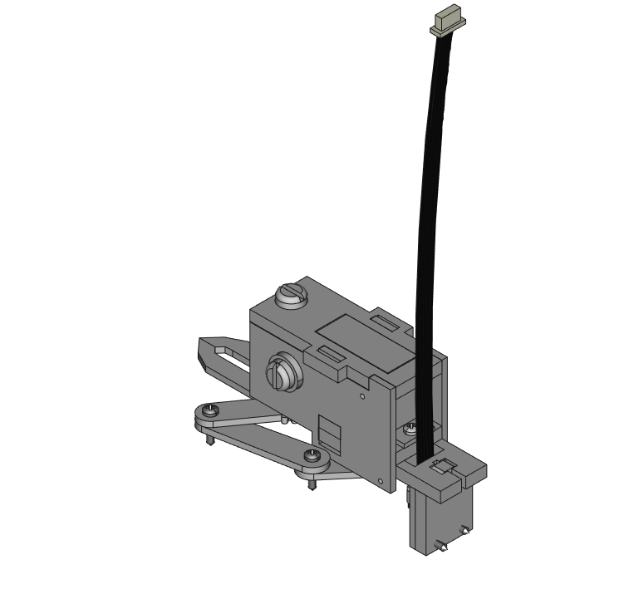

**STEP 37**: Use 1 M1.4x8mm screw and 1 small metal washer to mount the TOF plate to the claw.

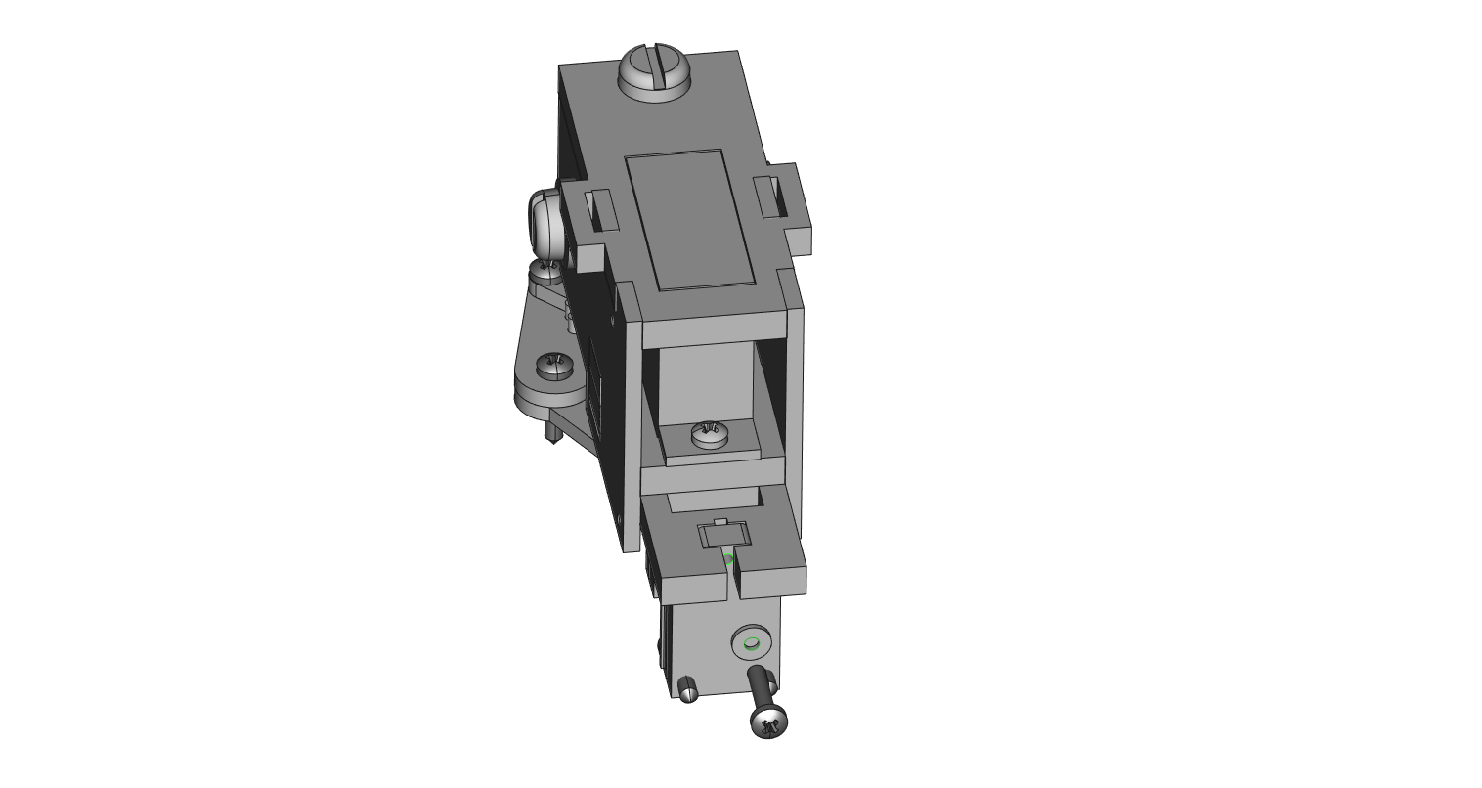

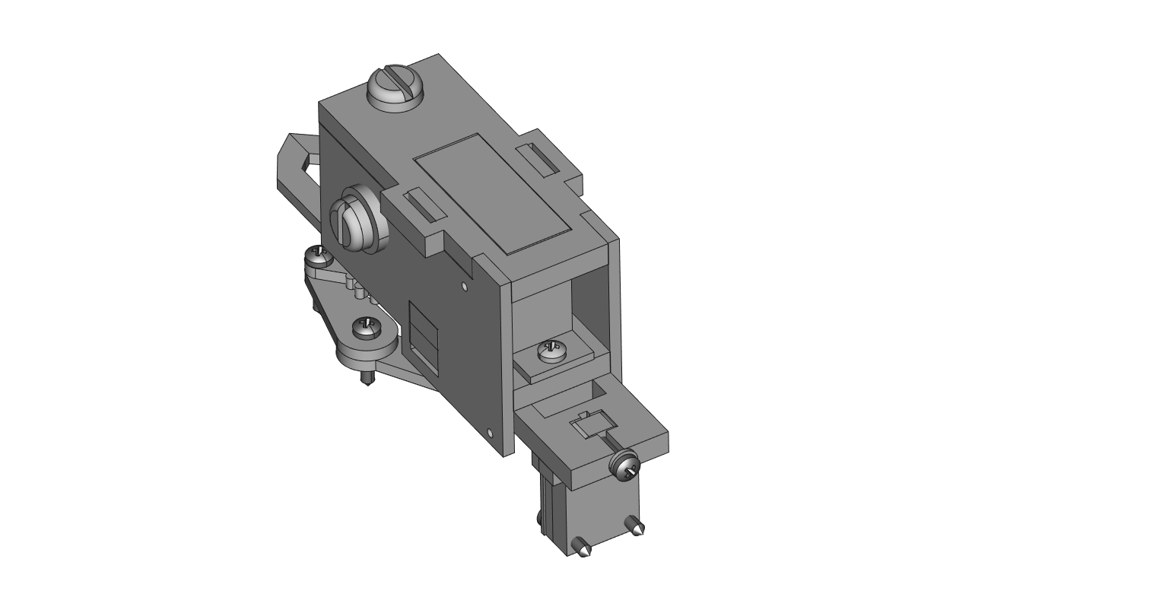

**STEP 38**: To mount the claw to the arm, use the bottom most hole on the claw and 1 M1.4 x 8mm screw through the end of arm piece A9.

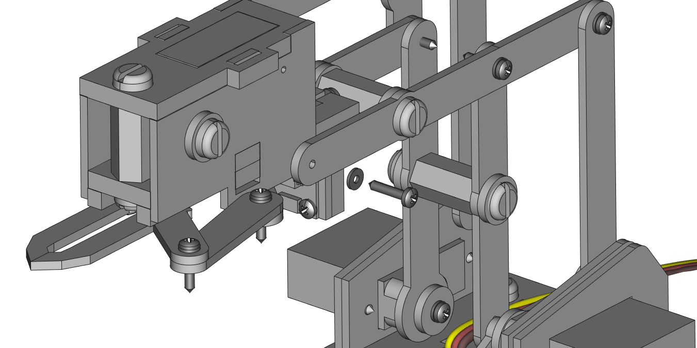

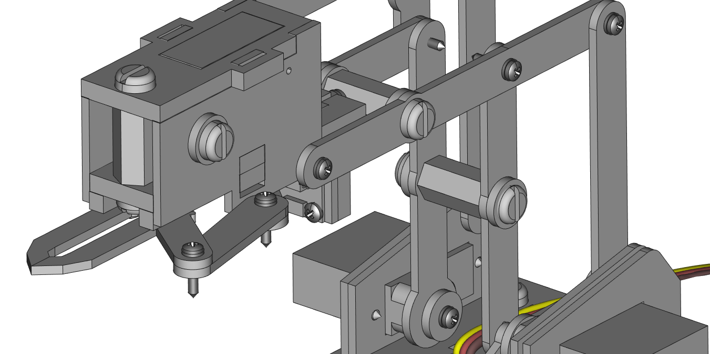

**STEP 39**: On the other side of the claw, also put 1 M1.4 x 8mm screw through A7 into the claw in the bottom most hole.

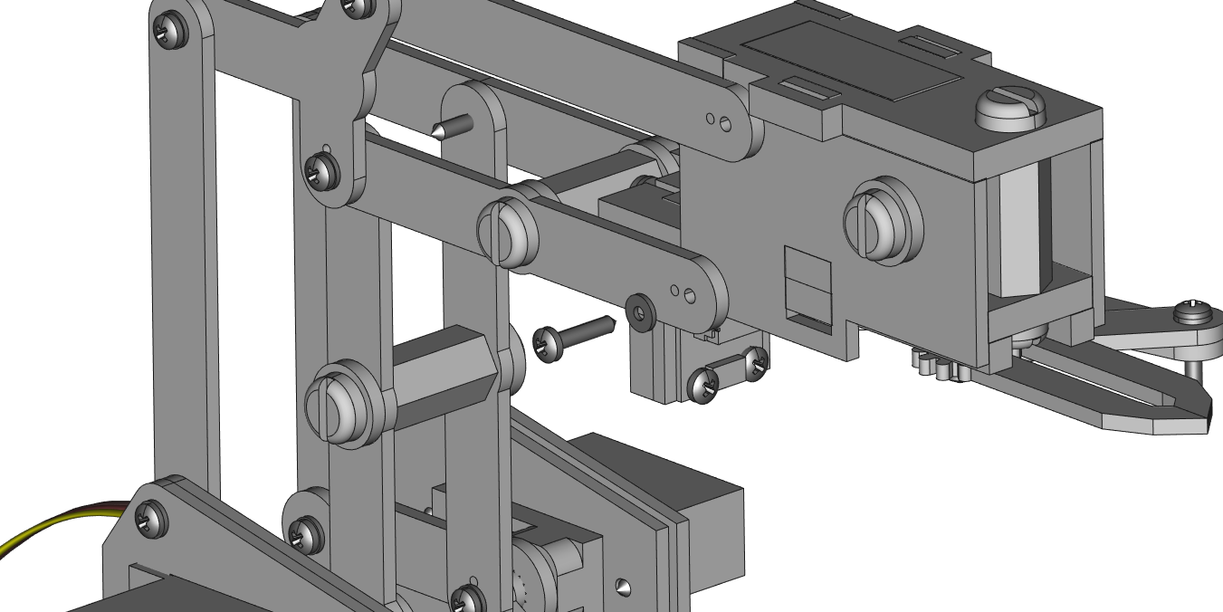

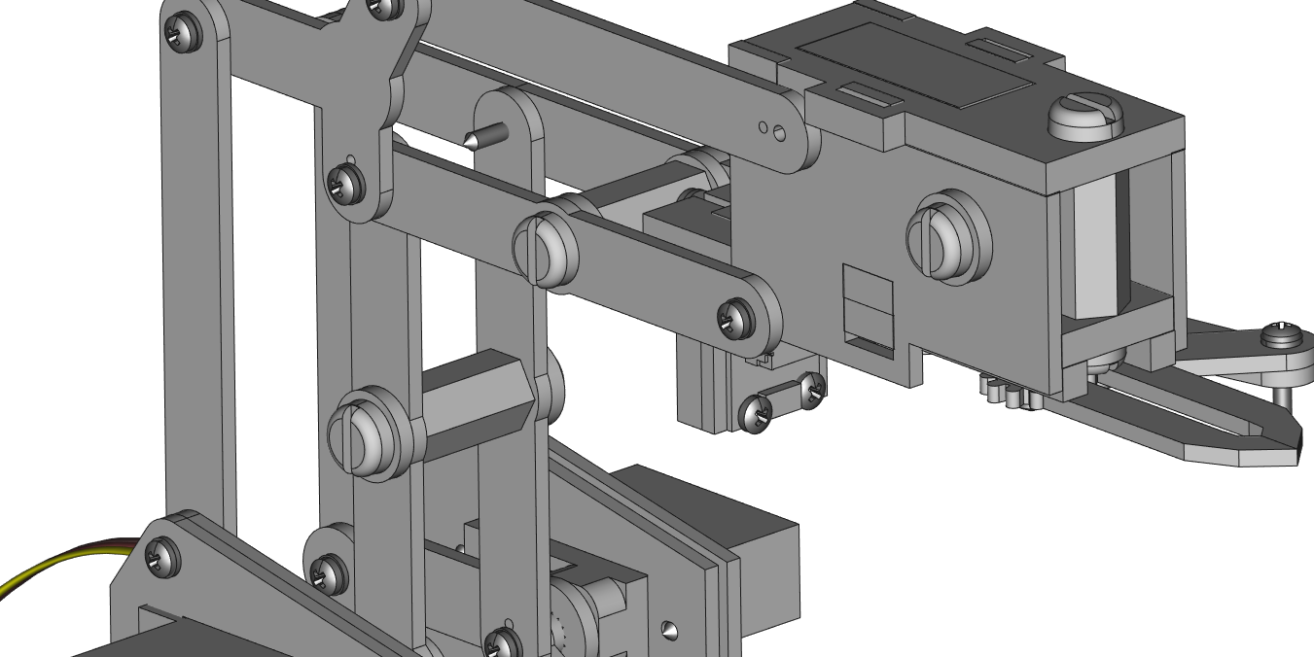

**STEP 40**: Use 1 M1.4 x 8mm tapping screw to thread it through a thick hex acrylic spacer part S, and through arm part A8 then the wall of the claw.

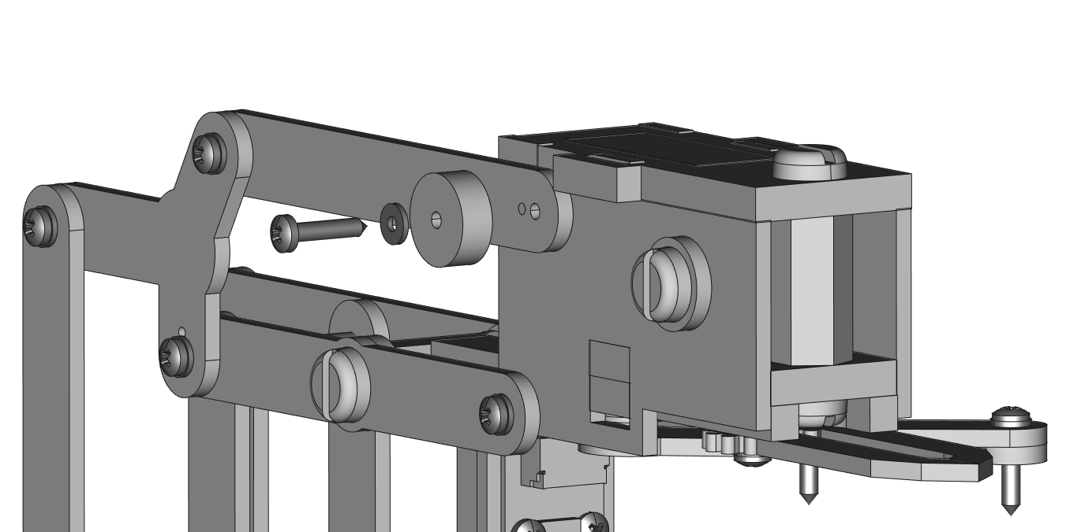

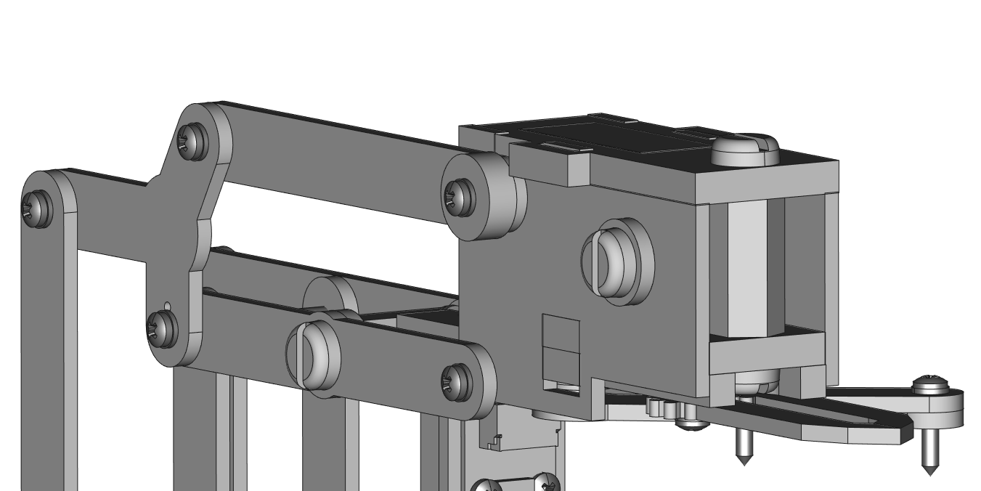

**STEP 41**: Use 1 large two-wing servo horn from any servo kit and mount it to the top of the car.

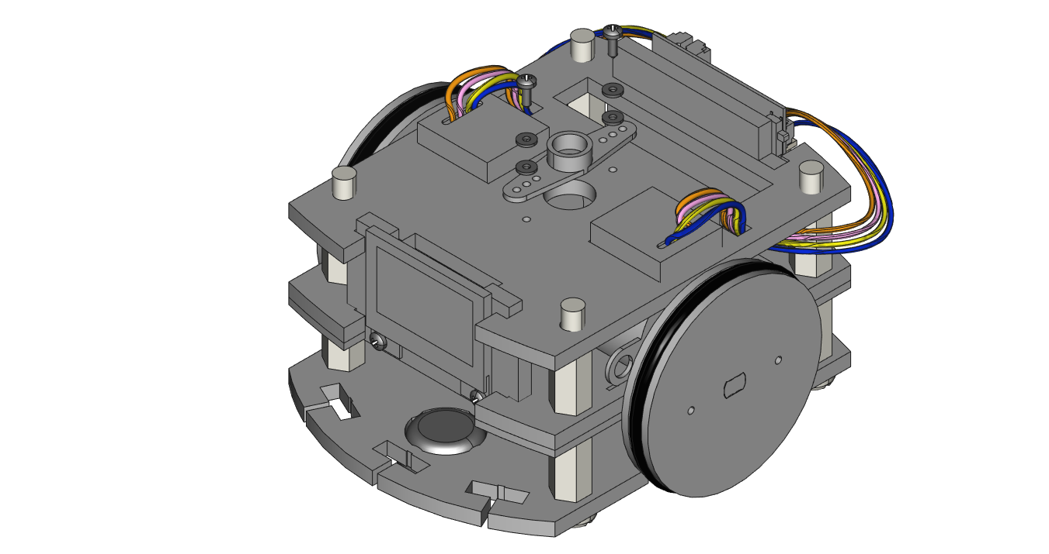

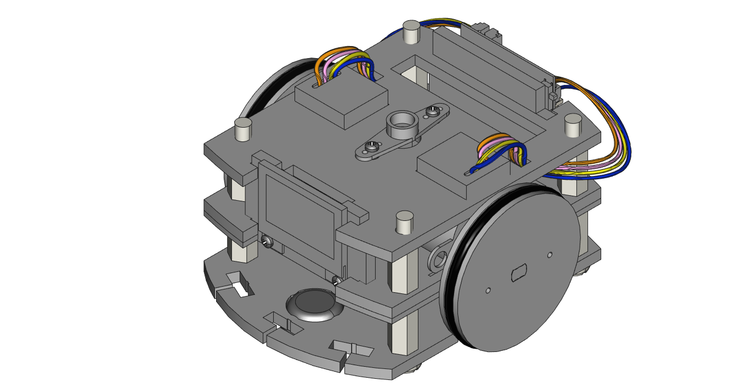

**STEP 42**: Before mounting the arm and claw to the car, use 4 female-to-male hex spacers on the four 1.5” nylon screws on the car. Place a thin acrylic spacer on each spacer.

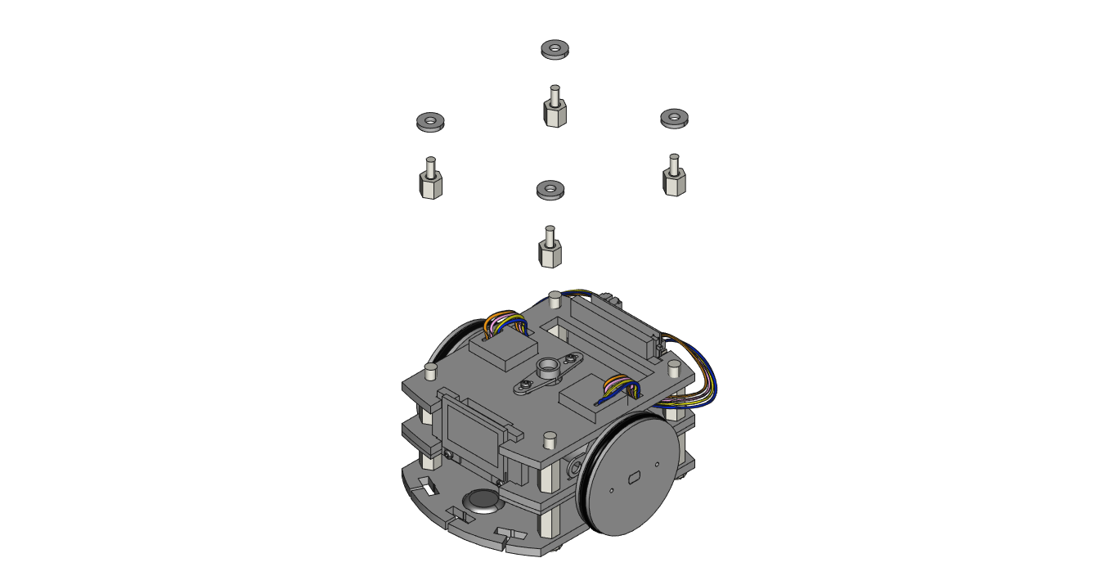

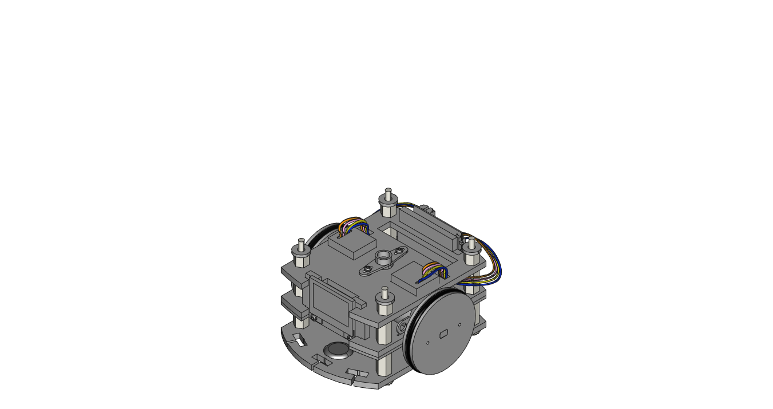

**STEP 43**: If it hasn’t already been done, insert a battery into the rear slots on the car. Looking at the RobotZero from behind, the battery connector is on the top left of the board.

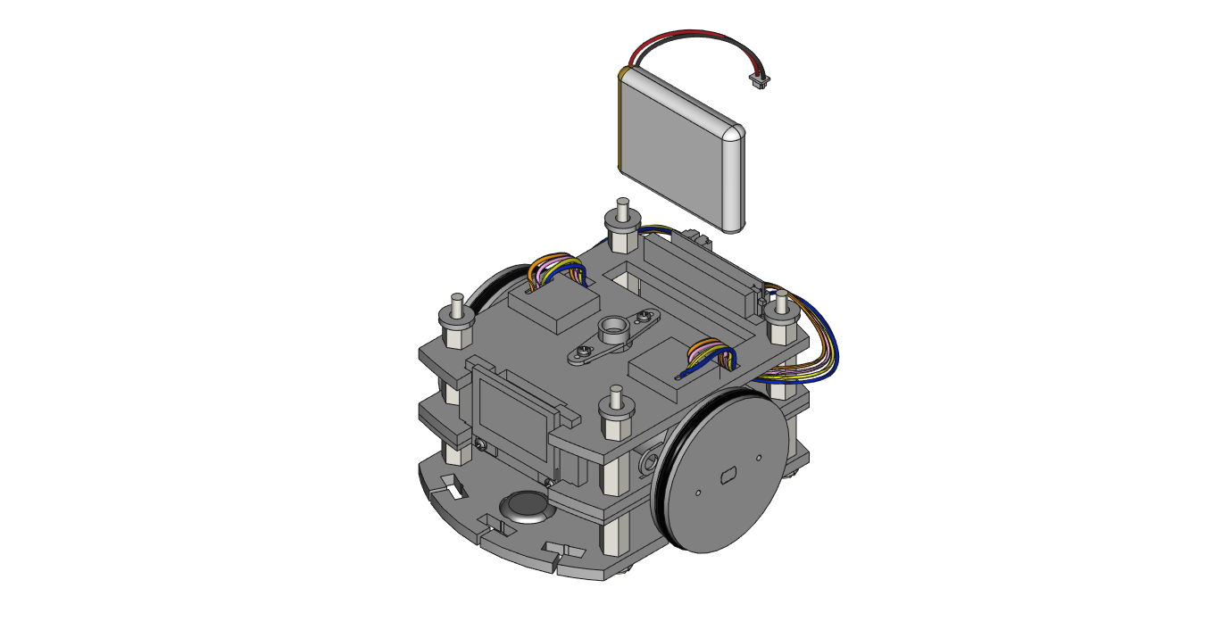

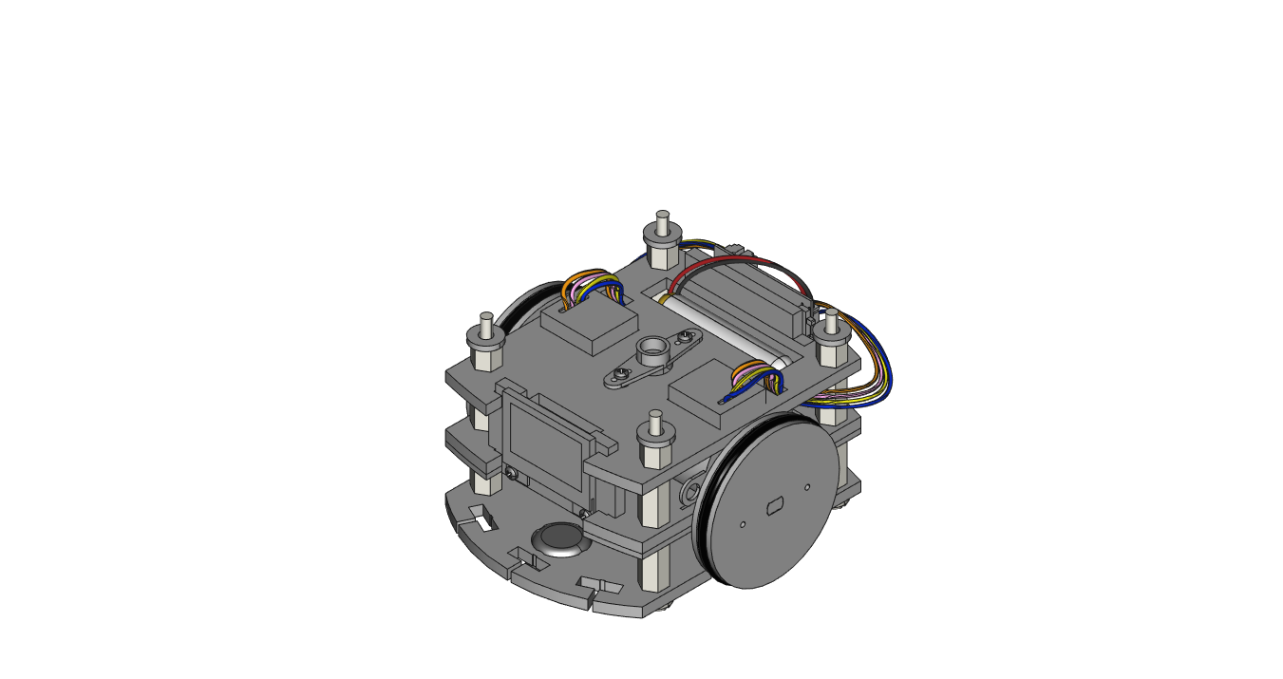

**STEP 44**: Mount the arm and claw to the car by inserting the female-to-male hex spacer threads into the four corner holes on the large plate AB8. Make sure to push the bottom servo into the servo horn that is mounted on top of the car.

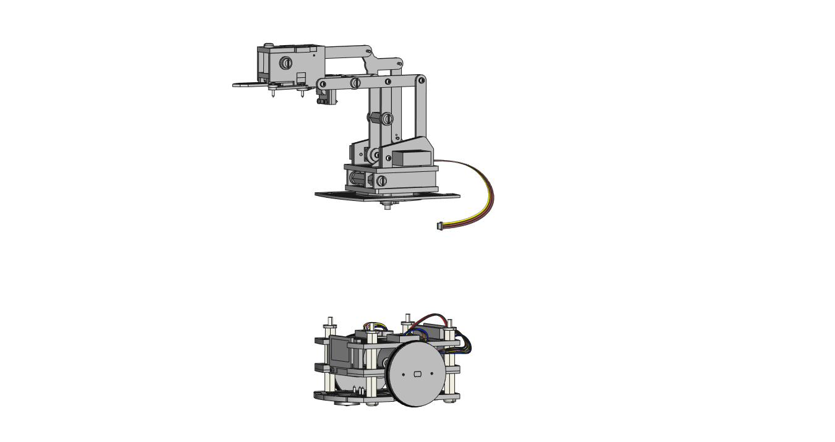

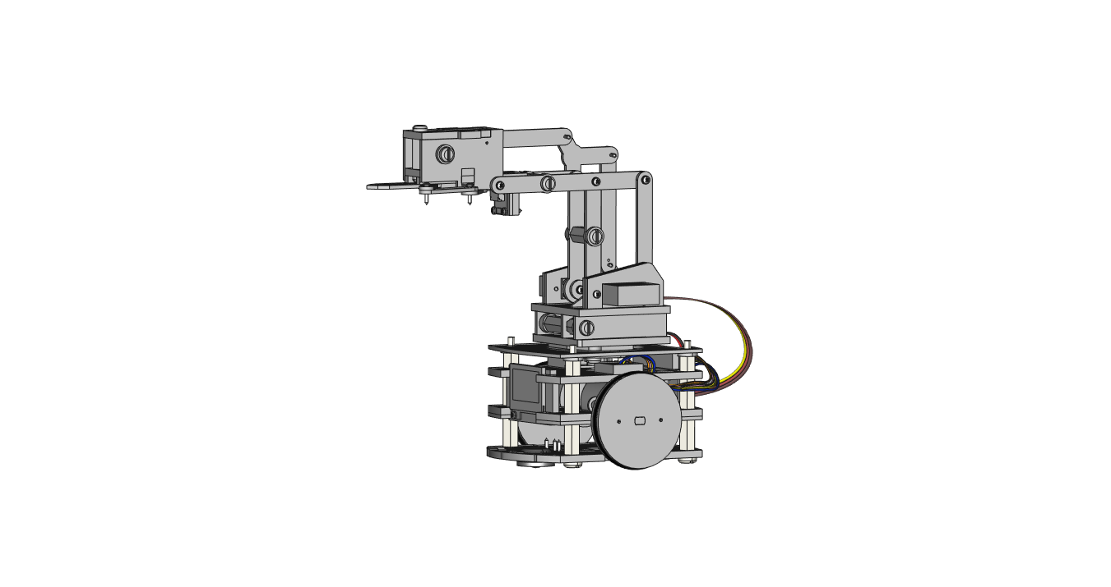

**STEP 45**: Secure the arm to the car using 4 metal hex spacers on the female-to-male spacers.

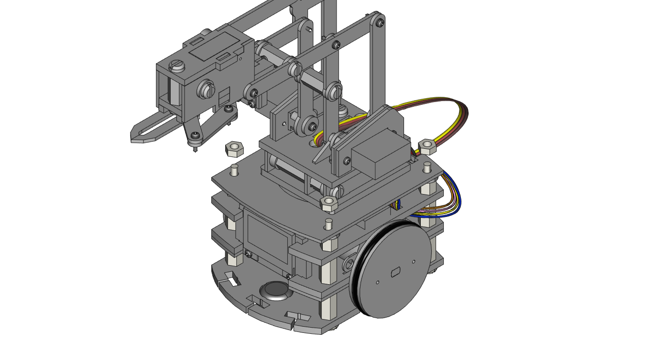

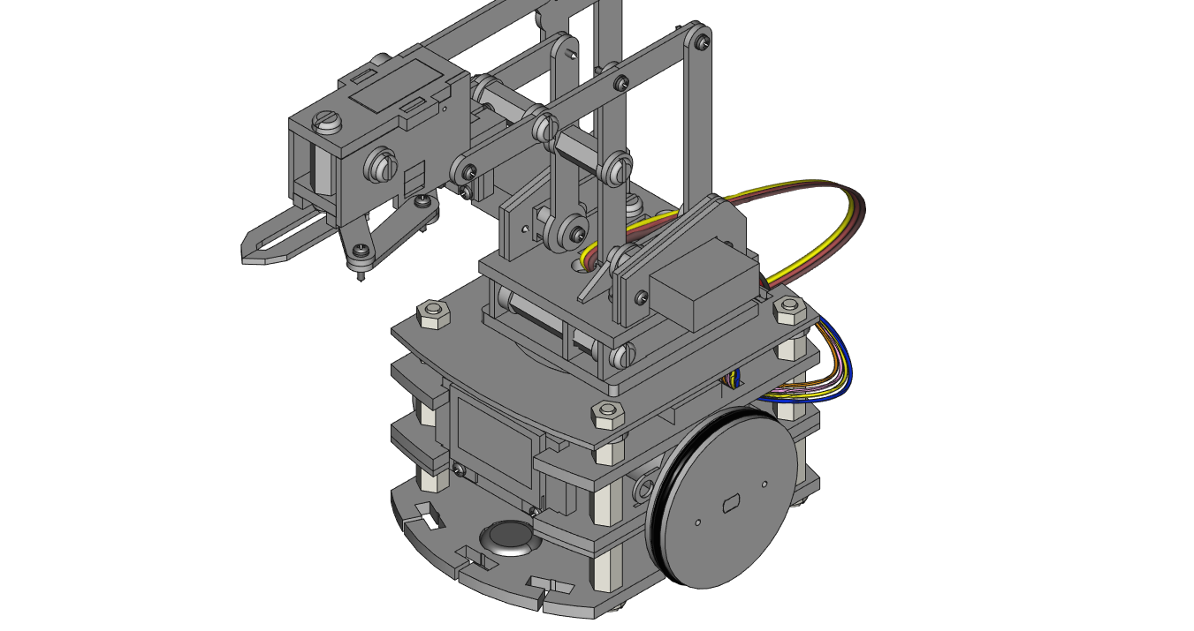

**STEP 46**: Up until now, only the base servo wire has been shown to reduce clutter. The four images below show how each servo is connected. (1) The arm base servo that helps mount the arm to the car is plugged into the bottom left port in the image below, (2) the claw servo is plugged in above that in the top left port. On the base on the arm, (3) the servo mounted horizontally on the left is plugged into the top-right port and finally (4) the right-most servo in the base is plugged into the bottom-right port.

